Volo’s Guide to Getting Murdered

Foreword
It had to happen eventually, Volo’s years of being a prolific scholar and middling wizard has caught up with him. Volo’s Guide to Getting Murdered is a one-shot with replayability in the style of Waterdeep: Dragon Heist, with four unique villains to be at the heart of this adventure.
I’d like to thank the many collaborators on this project that started as a throwaway remark on a podcast. Justice has guided me through this product, been eternally patient, and above all else a joy to work with. Also Anne, who was kind enough to answer my many layout questions and the chance to see her uncanny work ethic first hand!
My last thanks is to you; in picking up this product, you've helped add value to the hours we've spent lovingly putting this all together. Hopefully there is enough of a mystery to unravel, one that yourself, and your party will enjoy.

Credits
Design: Matthew Whitby
Editor: Justice Arman
Layout: Anne Gregersen
Interior Illustrators: Pat Maxton (@Doodle_Bags)
Additional Art: Additional art found within has been gathered from royalty free commercial images or created solely for the purpose of this document.

On the Cover
A depiction of Waterdeep’s Crest featuring a hand reaching out for help beside Volo’s iconic floating hat. Very much inspired by the fantastic work of Hyrdo74, created by Matthew Whitby.

Legal
DUNGEONS & DRAGONS, D&D, Wizards of the Coast, Forgotten Realms, Ravenloft, Eberron, the dragon ampersand, Ravnica and all other Wizards of the Coast product names, and their respective logos are trademarks of Wizards of the Coast in the USA and other countries. This work contains material that is copyright Wizards of the Coast and/or other authors. Such material is used with permission under the Community Content Agreement for Dungeon Masters Guild. All other original material in this work is copyright 2019 by Matthew Whitby, Justice Arman, Anne Gregersen and published under the Community Content Agreement for Dungeon Masters Guild.

Preface
Well met!  And who am I, you ask?  Volothamp Geddarm at your service, proud author, adept wizard,¹ and something of a realm-spanning celebrity. I’ve explored the far corners of long-forgotten maps,² uncovering truths lost to the wind.  We live in dangerous times.³ I have no doubt you’ve heard the rumours of curses, draconic invasions, competing factions, or assaults from the Nine Hells themselves.⁴ As such, it has never been a better time to have associates, allies, and, dare I say it, friends. ⁵  The process of making friends is narry an easy one, and for those struggling I shall shout across every rooftop the clear necessity this tome of essential knowledge.⁶ It is as detailed as it is comprehensive, from meeting people along the roads, within markets, or the many vast cities, there is assistance for every occasion! ⁷  If this tome garners you fame, fortune, and friends, I humbly request that you tell your newly acquainted friends or business partners about this book.⁸ It is only through your continued patronage that I have the chance to pen such useful guides. As always, I remain your humble scribe and obedient servant, and am now (and blessed by the gods for a continually being),  Volothamp Geddarm⁹ | Notes from Elminster Aumar, Archmage of Shadowdale, Senior Advisor to the open Lord of Waterdeep  - Adept? I shall believe it when I see it.  - I recall with some clarity handing Volo a multitude of maps I very much remembered.  - Dangerous for boisterous scholars perhaps.  - Less of an assault, more of a city wide kidnapping. Further citations required.  - Despite my jabs, this lad has proved to be amicable throughout our strictly professional encounters.  - “Essential” is Volo’s classic misconstruing of words once more. His “studies” into nymphs was also said to be essential.  - In the infinite realm of possibilities, outcomes, and situations, I find this claim doubtful at best.  - Ah yes, let me tell my newly acquainted friend of the book I used to subtly trick them into being my friend.  - Volo, for all his flaws (of which I stopped documenting due to lack of ink), has proven himself constantly to be a scholar of value. Trustworthy, too.

Adventure Overview
Volo’s Guide to Getting Murdered is your classic murder mystery adventure, complete with some political intrigue. Characters meet Volo and schmooze with some unsavoury company. Suddenly the famous author is murdered, and the real investigation begins!
There is also the opportunity to run this adventure multiple times, with Volo murdered by someone different each time, promising a slightly unique experience! The adventure is intended for parties of 4th or 5th level. It is broken into three core parts:

- A Party to Die For. Waterdeep is rife with rumours and gossip surrounding Volo’s upcoming release party, and the adventurers just so happen to have highly coveted invitations.
- Volo’s End. The party begins well-intended, but a few individuals seem to be up to something. Volo disappears from the party, only to be found a little while later - dead!
- To Catch a Killer. By some strange happenstance, the celebrations are teleported to the Ethereal Plane. This keeps the adventuring party and all the culprits trapped until Volo’s murder can be solved.

Adventure Background
Prior to the events of this adventure, Volo has certainly been a busy man. There are two core events that have contributed to the four culprits wishing Volo’s untimely demise.

Volo’s Latest Book
The entire party is to celebrate Volo’s latest book, aptly titled Volo’s Enchiridion to Making Friends. The book documents ways to make travelling across the world a safer place, by making friends and allies in the most unlikely of ways. It features its fair share of half-truths, such as techniques to instantly convince wildlife such as owlbears to be docile without the use of magic.

The Friends (and Enemies) We Make
Volo’s latest book had him trying his hardest to rekindle old friendships or make allies in the most unexpected places. Unfortunately for Volo, the process of making certain friends makes just as many enemies elsewhere. Unbeknownst to the scholar, angry individuals cannot see a better opportunity to take their revenge than at Volo’s next book release party.

Running the Adventure
As always, to run this adventure it is recommended to have the D&D fifth edition core rule books: Player’s Handbook, Dungeon Master’s Guide, and Monster Manual. Any mention of a creature with its name in bold is recommended to look up the corresponding creature’s stat block either in the Monster Manual or appendix B. The same is true for any magical items, which can be found within the Dungeon Master’s Guide unless specified otherwise such as in appendix A.

Text that appears within a box, like this, is intended to be read aloud or paraphrased for the players when their characters first arrive at a location. It describes the contents of a room or an event.

One recommendation is to read through the adventure and familiarise yourself with the timeline and maps before playing, making notes of key information or summarising events. The adventure has been laid out for ease of use, so prepare for your session however you see fit!

Anyone Could’ve Done It!
Volo, in his quest to document and outline all the ways to make friends, has unfortunately made his fair share of enemies. This means that just about anyone invited to the party could have unknown desires to harm the legendary scholar.
The adventure has been designed with this in mind, allowing for any of the potential culprits to have killed Volo. Each one has a motive, the ideal opportunity to strike, and countless other people to point fingers at.
As the characters experience the party, there are arguments and suspicious sightings before the eventual discovery of Volo’s demise. Everyone finds themselves trapped within the Hawk Man statue as it teleports back into the Ethereal Plane, somehow mysteriously linked to Volo’s sudden death.

Choose Your Villain
Volo’s Guide to Getting Murdered offers four villians who could’ve perpertrated Volo’s murder.
- Soluun Xibrindas. One of Jarlaxle’s lieutenants, wishing to defend his leader’s honour and end Volo’s gossiping about Jarlaxle’s (or his aliases’) activites.
- Pirene the Half-nymph. During Volo’s study of nymphs, a horrible misunderstanding led to a child being raised without their father. Pirene is Volo’s daughter and wishes vengeance for what she believes Volo did to her mother.
- Davil Starsong. The leader of the Doom Raiders and Master of Negotiations within the Zhentarim. Davil wishes Volo dead for his involvement in Renaer Neverember’s rescue, which resulted in Davil being briefly arrested.
- Hailee Dunn. A northern woman whose town was impacted by Volo’s negative review. Hailee wants that rectified, however she can.

For more details on each of the potential culprits, or their account of events if interrogated, read the Culprits section found further within this book.

Seasons
This adventure unfolds differently depending on the villian chosen for this one-shot, or as part of the Waterdeep: Dragon Heist campaign. However, because every potential villain may be attending the party, you are free to switch them at any point.

Spring
The typically colourful and warming Spring hides the sinister figure that is Soluun Xibrindas, one of Jarlaxle Baenre’s three lieutenants within the Bregan D’aerthe faction. A cruel and sadistic individual, Soluun heard word that Volo had spoken poorly of Jarlaxle -an offence that Soluun believes should be punished. This season uses subtlety, misdirection, and a repulsive villain.

Summer
The warm days and calm nights that summer brings also introduces Pirene the half-nymph. Pirene is none other than Volo’s secret child, here to garner all the attention and ultimately avenge the slight against her mother. This season promises a tragedy of misunderstanding, and just a touch of patricide.

Dressed for the Occasion
While each season brings a unique villain to the party, it also has some minor changes to the clothing of the guests, and decorations. Because at the end of the day, no one will be able to live down attending a winter ball in a summer suit. Just think what the nobles would say!
The following details can be noted depending on the season:
- Spring. Flowers aplenty, with sofer yellows, reds, and greens galore. The winter cloaks have been thrown off, as now more fashionable apparel can be worn.
- Summer. Clothes to balance the summer heat, flowy dresses and ruffled shorts. Cooled drinks are made readily available, as being inside a statue can get rather heated.
- Autumn. Colours to match the autumnal hues: oranges, browns, and yellows scatter the party. There is a mixture of summer, spring, and winter clothes, mostly as guests use this as a last chance to wear their favourite clothes.
- Winter. Whites and cold blues fill the ballroom, with the occasional splash of colour from those desperate to stand out. Thick fur cloaks, gloves, and jackets are abundant, while those without huddle close to the roaring fireplaces.

Autumn
The autumn season brings Davil Starsong, a Zhentarim agent who organised the abduction of Renaer Neverwinter. Unfortunately, a series of mistakes led to Ranaer getting away and that only damaged Davil’s reputation with the Black Network. Since it was Volo who instigated the Watch and adventurers to search for Renaer, Davil has set out to ensure that Volo doesn’t meddle with Zhentarim matters ever again. This season brings a carefully calculated assassination, with multiple players to add intrigue.

Winter
Ice and snow lay claim to Waterdeep, as howling winds usher in Hailee Dunn from Lonelywood of the Ten Towns. She’s seen her town begin to dwindle, as Volo’s Guide to the North left a multitude of unfavourable reviews - reviews that were written based on Hailee’s childish lies when she first met Volo. Now, she blames everything on that one pomposs scholar, who needs to set things straight, or else. Selecting this season brings a harsh and aggressive killer, someone who is led to extremes by their own actions years ago.

Adventure Hooks
The entire adventure centres around the release party located in Sparuant Tower, and there are a few ways to get the characters into the most exclusive party of the year. Below are just three suggestions:

A Secret Invitation
The adventurers are located by a courier who delivers an unmarked but sealed envelope. Inside are invitations for everyone to Volo’s extravagant book release party, along with a handwritten note that simply reads “Attend with utmost vigilance.” It doesn’t appear as if it was from Volo despite it being his party, but discovering who sent the secret invitation only adds to the mystery of it all.

Faerûn’s Up-and-Coming Heroes
Volo is one to maintain an appearance in social circles, if not to brag about his countless expeditions, than to keep up to date with the trends of a city. He may have heard of the characters’ antics in Waterdeep and couldn’t think of a better group to join in the celebration of his next greatest book release.

Volo’s “Best” Friends
If following or during the events of Waterdeep: Dragon Heist, the party may have already encountered and assisted Volo. In which case, they will either get a personal visit from the man himself or a warmly worded letter inviting them to the Hawk Man walking statue of Waterdeep for his newest book release.

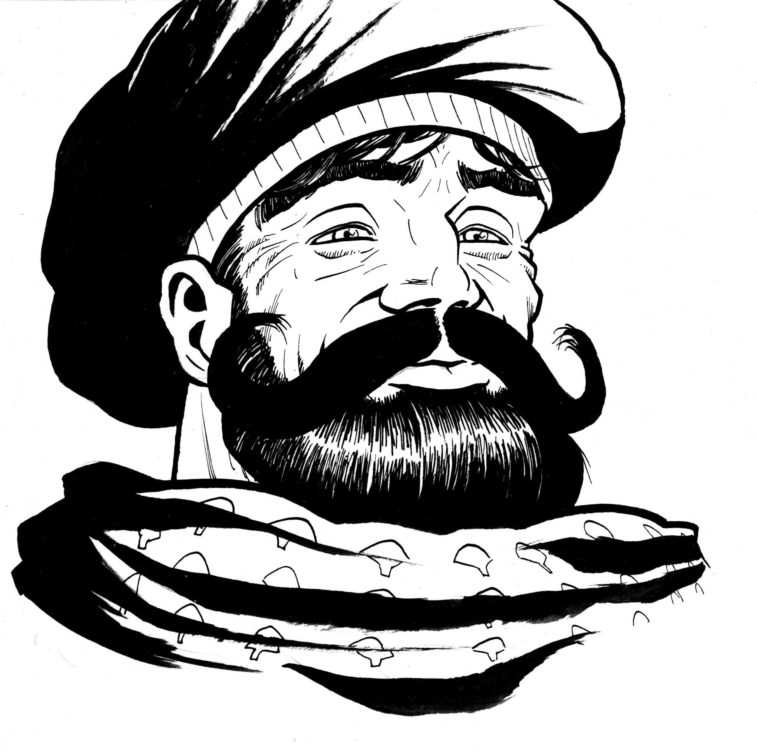

Volothamp Geddarm
The infamous world traveller, what can be said about Volothamp Geddarm that he hasn’t already told anyone he’s ever met? Despite his boisterous renown, Volo is a soft-hearted fellow who truly cares for his friends. His body of work from Volo’s Guide to the Sword Coast to Volo’s Guide to Monsters speaks for itself, providing information about the cities of Faerun or the creatures who inhabit it.
He’s a middling wizard, whose iconic appearance is a floppy azure hat and extended white scarf. Being quite the socialite, Volo has a charming disposition, and he makes no attempt to hide how well travelled he is or the powerful friends he has made. Volo’s thirst for knowledge, or at least being known to know, is what drives his insatiable curiosity. A curiosity that his dear friend Elminster says will be the death of him.

Personality Trait: Braggart. I have the wildest of tales to tell, each one entirely true!
Ideal: Friendship. The bonds of friendship we make, and the books I’ve written, will last forever.
Bond: Friends. There’s nothing I won’t do for a friend in need.
Flaw: Inflated Ego. My work is instrumental in making the world a better place!

Sparaunt Tower - Hawk Man
There are few locations within Waterdeep more exotic or exciting as the now-dormant Walking Statues. Believed to be the creation of Ahgharion, the founder of Waterdeep, the Walking Statues were summoned in defence of the great city. For the longest time, seven of the eight Walking Statues were hidden within the Ethereal Plane and only the Spellplague of 1385 forced six of them to appear. Unexpectedly, the colossus sized statues proceeded to demolish large chunks of the city, and it was only after the Swordmaiden, the Hawk Man, and the God Catcher were stopped by Khelben, the Blackstaff at that time, that the unexplained rampage ended.
They are considered to be Watderdeep’s last line of defence and under the control of the Blackstaff, the title of the Archmage of Waterdeep. Currently that title is held by Vajra Safahr, only she can animate the statues to obey her commands. However, all the statues have been dormant for over a century, and Vajra is confident that Waterdeep can defend itself without resorting to animating a Walking Statue.
As a result of the inactivity, some residents have begun to take liberties such as building atop, or even so far as hollowing out to build inside one of the statues. However, none have been such an outward sign of wealth and power than Lady Sparaunt’s renovations of the Hawk Man. Six lavish apartments were carved from inside the Hawk Man statue, and the structure was renamed Sparaunt Tower.

Location History
Sparaunt Tower is located inside the hollowed-out Hawk Man colossus statue, from the pelvis up to the top of the hawk’s head. The main entrance to the tower is embedded into the statue’s left hand palm, and the only means of accessing the tower is via a rope ladder or lifted chairs.
It's now home to many wealthy residents of Waterdeep’s Castle Ward. The tower gained its name from Lady Sparaunt, who supervised the renovations personally. Friends of Lady Sparaunt - or patrons with enough funds - rent the tower for balls, festivities, or a prolific author’s newest release party.
It bears the resemblance of an aarakocra, with wings tucked tightly behind its back, with its left arm outstretched as if to motion “stop”. However both its right foot and right arm have been destroyed, causing the entire tower to tilt towards the north-east. Despite the statue’s outwardly tilt, each floor inside the tower is perfectly level.

Sparaunt Tower Features
The following general features apply to Sparaunt Tower:
Structure. Sparaunt Tower has six stories.
Ceilings. Its rooms have 12-foot-high ceilings and 7-foot-high doorways.
Lighting. Unless otherwise noted, all areas are brightly lit by wall sconces.
Climbing. Any attempt to climb the outside of the Hawk Man statue without equipment requires a successful DC 15 Strength (Athletics) check.
Entrance. The main entrance to the tower is a doorway carved into the statue’s palm. In the courtyard below, ringing a small copper bell notifies a guard who then lowers a platform to raise visitors up to the entrance.
Doors. Each of the doors in the tower is made of iron-bound oak and has AC 16, 27 hit points, and immunity to poison and psychic damage. If a door is locked, it can be picked by a character who makes a successful DC 15 Dexterity check using thieves’ tools, or it can be forced open with a successful DC 20 Strength (Athletics) check. Lady Sparaunt and her two co-chief house servants hold keys to every room in the building.
Windows. The entire tower is devoid of windows, except for at the head of the statue where it is possible to stare out of the three-foot wide windows set into either eye. There are multiple latches on the windows. A successful DC 16 Dexterity check using thieves’ tools opens one of the windows from the outside.
Pillars. Each room has a number of 5-foot-wide, square stone support beams connected to arches for structural support to the statue.

Occupants of Sparaunt Tower
Sparaunt Tower is home to some of the richest people of Waterdeep, as to be expected from housing found within one of the wondrous Walking Statues. As such, there is a cavalcade of staff ready and willing to tend to every need of those within the tower. Everyone is ordered to be on their best behavior for Volo’s party, as many influential people have been invited to come celebrate, and a good impression only serves to improve Lady Sparaunt’s renown.

Lady Sparaunt
The owner of Sparaunt Tower is something of an enigma. Lady Sparaunt is rarely seen in public, and very little is known about her. Even her first name is a mystery to the public. Rumours say that she has been in Waterdeep for a dozen years, others suggest she simply turned up to begin building in the Hawk Man. The truth is unknown.
Appearance-wise, Lady Sparaunt is incredibly unassuming by design. Lady Sparaunt is of indiscriminate age, but it would be fair to assume her life has been extended via magical means. She doesn’t wear clothes to signify herself as nobility or rich; as a result, only her staff can identify her.
During the party, Lady Sparaunt idly patrols the rooms, making chit chat when she sees fit. Those who converse with her may notice the slight white glaze of her eyes due to her habitual blank stares.
Lady Sparaunt is a neutral human female diviner (VGtM p213).

Personality Trait: Secretive. Most people know very little about me. I intend to keep it that way.
Ideal: Control. Do you know birds always know the wind in which they fly? I foresee the wind.
Bond: Remnis. My studies led me to Remnis, I work in his name.
Flaw: Blank Stare. Forgive me, I did not mean to appear as if I was staring through you. My mind was elsewhere.

Head Servants
There are four head servant roles within Sparaunt Tower, all of which respond directly to Lady Sparaunt. All staff such as servants and guards live outside of the tower, commuting early in the morning or late at night depending on their shift. They are noted as following:
- Tylfine & Aralkin Summerlin. A pair of identical twin neutral good female half-elf spies. Tylfine and Aralkin are Lady Sparaunt’s co-chief house servants. They tend to and oversee everything within the tower, including directing all housekeeping services, gathering residents’ desired meals, and planning a wide array of evening entertainment. They often switch roles, much to the confusion of the remaining staff. Despite being identical, the pair can be differentiated by the colour accents of their uniform; Tylfine’s is red, while Aralkin’s is yellow.
- Frug Knuckespring. A lawful good male halfling bandit captain. Frug, the entrance guard, stands on the platform extending from the statue’s palm, raising and lowering residents to the tower, overseeing all who can enter the tower. He uses his incredible strength to follow Lady Sparaunt’s instructions to the letter.
- Wehltrin Do'ervs. A chaotic neutral non-binary drow berserker. As the Head Chef of Sparaunt Tower, Wehltrin is incredibly serious about their role. They are a perfectionist and quick to anger towards anything that would impede their perfection.

Other staff include seventeen guards, six chefs (commoners), and twenty servants (commoners) of differing roles. Wishing to make a good impression Lady Sparaunt has all members of staff working for the duration of the party.

Invited Guests & Denizens
Volo has invited more than fifty privileged guests, people of all sorts of backgrounds and occupations, to attend his book release party. In addition, there are eleven residents of Sparaunt Tower in attendance, including Lady Sparaunt. Some of the denizens have joined in the celebration - who doesn’t love a free party? - whereas others opted to stay within the safe confines of their apartments.

Sparaunt Tower Locations
The following locations are keyed to map 1.1.
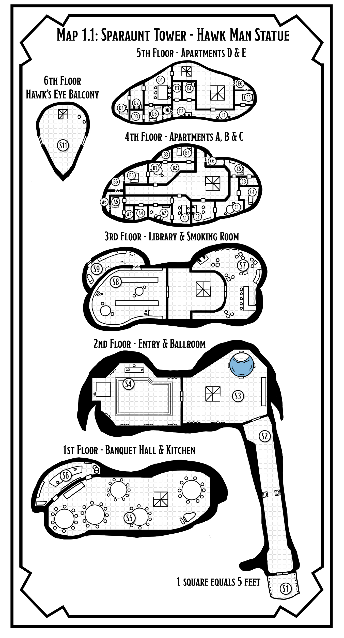

S1. Hawk’s Hand Entrance
Approaching any of the Walking Statues of Waterdeep is always a case for wonderment, and today is no exception. Before you is the tilted colossus known as the Hawk Man, its left hand outstretched as if commanding you to stop. The festivities have clearly begun, as an orderly queue lies ahead. Bundles of people step into a wooden cart which is cautiously lifted towards the entrance embedded into the statue’s palm.

Within the Castle Ward, at the base of Sparaunt Tower is a small courtyard with four L-shaped flower beds outlining the space. Because of the Hawk Man’s perceived perilous leaning, the centre of the courtyard is directly under the statue’s outstretched palm.
Party Guests. A dozen guests have formed an orderly queue waiting for the lift to descend and carry them up into Sparaunt Tower. In front of them is a Sparaunt guard, who inspects everyone's invitation before letting them board the cart. If the characters do not have their invitations, only a successful DC 14 Charisma (Persuasion) check or a 5 gp per person bribe allows them passage. Any attempts to threaten the guard are met with calls for the City Watch.
Wooden Cart Lift. A 10-foot by 10-foot wooden cart is held up by a series of chains. It holds up to five medium-sized passengers per voyage. Each journey takes roughly ten minutes to lift up and lower the lift. There are runes at the bottom of the cart that can be identified with a successful DC 15 Intelligence (Arcana) check as reactive runes that cast feather fall on every passenger should the cart ever fall.
Frug Knucklespring. The halfling entrance guard manually heaves up each cart, wearing thick cog-covered metal gloves. He is assisted by two other Sparaunt guards. Despite being rather sweaty, Frug still bows patiently to each guest and welcomes them to Sparaunt Tower. Frug asks all guests to relinquish any visible weaponry, which is locked and stored within a crate in the entry hall (area S2). However, given the number of guests, Frug can be convinced to let the adventurers keep their weapons after a successful DC 15 Charisma (Persuasion) check.

S2. Entry Hall
The narrow hall has the following features:
- An azure rug runs the length of the statue’s arm towards a closed door at the far end.
- Halfway down the hall, a pair of miniature renditions of the undamaged Hawk Man Walking Statues point towards the entrance. They are mirrored on each side of the hallway, with one holding its left arm up, while the other holds its right up.
- Two Sparaunt guards flank the far door, dressed in fine orange regalia with every piece of metal showing polished to near perfection.
- A locked crate rests in the corner of the room. It is filled with assorted fine ornamental sabers, and functional daggers. The lock can be picked by a character who makes a successful DC 15 Dexterity check using thieves’ tools, or it can be forced open with a successful DC 20 Strength (Athletics) check.

S3. Foyer
The centre of the foyer is dominated by a 15-foot-wide spiral staircase. The back of the room is dominated by a functioning fountain depicting the Hawk Man, that reaches from the ground to a foot below the ceiling. Four Sparaunt guards stand within the room, two flanking the grand marble staircase, while the other pair guards the entrance into the ballroom. There are four exits to this room:
- A wooden door leads back into the Entry Hall (area S2).
- A golden filigree set of open double doors yield for the spacious ballroom (area S4).
- The spiral staircase leads upstairs to the 3rd floor (area S7 & S8) or downstairs into the banquet hall (area S5).

S4. Ballroom
The expansive ballroom contains the following noteworthy features:
- Four servants stand with trays by the entrance, half of which contain flutes of wine or champagne, while the other half hosts a collection of smaller entrees.
- The polished wooden flooring is painted with an image of the Hawk Man statue across the centre, with crests bearing images of the remaining Walking Statues of Waterdeep circling it.
- Regal azure curtains line the curved walls of the room like pillars with arches that reveal the gilded mirrors that fill otherwise blank wall spaces. The mirrors give the illusion that the room is far larger than reality.
- It is filled with three dozen guests. A fine assortment of characters, given Volo’s nact for making friends. The guests could be found standing in small circles mingling, or engaging in dancing as and when the music peaks.

Volo’s Book Signing. On the far side of the room, a chair and table has been placed. Atop the table are four stacks of Volo’s newest book, along with a quill and ink for Volo to begin signing. A lone guard stands by them, but makes no effort to stop guests from taking a book.
Musical Stage. To the right of the book signing, is a collapsible wooden stage akin to those an entertaining troupe would use. Throughout the night, three different kinds of music are played:
- A young dwarven male with an orchestral voice sings beautifully as he plays on a grand pedal harp.
- A lively human female dances around the stage barefoot with a fiddle, enticing everyone to join in a jig of sorts. Her name is Nursi Goldsteel. She is secretly a Zhentarim spy.
- A pair of flute-playing elven males harmonise perfectly in what is a display of musical fencing as they try to out play one another.
Dancing Constructs. Four well-dressed magical constructs stand to serve as dance partners, they have the functionality to alter their clothing to fit the dance, and desires of their dancing partner. The constructs have an AC of 18, 10 hit points, and are idle when not engaged in dancing.

S5. Banquet Hall
The room has the following features:
- Two Sparaunt guards stand by the spiral staircase, while ten servers (commoners) tend to the needs of the guests as well as ferrying food or dirty plates to and from the kitchen.
- Five circular tables fill the room, each sitting ten people, covered in the finest collection of silverware.
- The room is a hive of conversation. Two dozen guests made their way here for the assortment of free food.
- A grand piano is tucked into one corner, where a finely dressed female dwarf (spy) plays soft music to accompany eating.

S6. Kitchen
The banquet kitchen is a flurry of action, smells, and sounds as all the chefs attempt to cater for the many guests. There are two entrances to this room from the Banquet Hall (area S5), however for staff the right door is treated as an entrance, while the left is the exit. The following are noteworthy features of the room:
- Any character who enters the kitchen must make a DC 10 Wisdom saving throw or grow peckish from the smell of the delicious cooking.
- The room has a centre island of wooden worktops and an occasional lit stove. Six chefs (commoners) cook a wide array of appetisers, meals, and deserts.
- Every few minutes a server from the hall enters the kitchen with trays full of dirty dishes, which are then replaced with food and taken out into the banquet hall.
- Wehltrin Do'ervs (see “Head Servants”) oversees everything, and there is rarely a moment where they aren’t shouting orders at the many chefs or servers. Any intrusion into their kitchen is met with a flurry of insults, before they start throwing pots and pans.

S7. Smoking Room
This room contains the following features:
- A twenty-foot long bar counter that is tucked into one corner of the room. A lone servant (commoner) fetches drinks, pipes, and assorted smokeweed from the cabinet behind the bar. Five bar stools stand opposite the bar.
- Cushioned blue armchairs are paired throughout the room, some by the wall while others occupy the centre of the room. Walking through the smoking room requires some weaving between the chairs.
- On the coffee tables between each chair are glass ashtrays, and lit incense burners to keep a refreshing scent of petals in the air. Despite this, the room still smells heavily of smoke. They also include a number of small marble statuettes of the many Walking Statues of Waterdeep.

Drinks & Pipes Cabinet. Behind the bar under lock and key, are a collection of fifteen different expensive drinks (ports, whiskeys, wines), ten wooden guest pipes, and three assortments of smokeweed. Unknown to the bartender, one of the bottles labelled “Elven Wit '' was poisoned months prior. Any creature drinking it must succeed a DC 13 Constitution saving throw or become poisoned. One type of smokeweed provided is labelled “Sleepy-Weed'' which if smoked causes the creature to have disadvantage against any effect that tries to put them to sleep until they finish a long rest.
Map of Waterdeep. On the northern wall hangs a canvas map of Waterdeep that covers the majority of the wall space. The map itself has no locations labelled. On closer inspection, a successful DC 16 Intelligence (Arcana) check reveals that the map is magical, enchanted with divination magic. Only Lady Sparaunt knows the command word, which if spoken will reveal the location of a creature that she knows, usable once per day.

S8. Library
The room contains the following features:
- Every available wallspace has been covered in floor-to-ceiling bookshelves, with only the highest of shelves not flush with books. As such, a faint musty smell of aging parchment fills the air.
- A brass pole encircles the room, from which two wheeled ladders can be slid around the room, to reach the higher shelves.
- Much like in the ballroom, a table has been provided for Volo to display his newest book and for potential signings.

Books. None of the books are magical, or really hold any value about 5 sp. However, a few may stand out to the adventurers:
- Volo’s Guide to Monsters - The book appears in poor condition, with multiple pages torn out, water damage, and crude phrases about Volo’s character written in the margins.
- The Truth of Matters - An expose written by an unknown author, the book writes about fabricated “scandals” of multiple well-known figures who’ve visited Waterdeep, including Volo, Dagult Neverember, Mirt, and Laeral Silverhand.
- The Rise of the Cassalanters - A recent book that details the somewhat sudden success of the Cassalanter family. The author only speaks appraisingly of the family and in the smallest of footnotes mentions how the publication of the book was funded by the Cassalanters.
Secret Door. The secret door to Sparaunt’s Aviary (area S9) can be detected by a character who makes a successful DC 19 Wisdom (Perception) check. The character discovers one of the bookshelves can be lifted to reveal a hidden room behind.

S9. Sparaunt’s Aviary
From the secret entrance in the library (area S8) exists Lady’s Sparaunt’s private aviary. An assortment of hawks, pigeons, and crows sit on perches scattered across the room. There are three steel cages, but all the doors have been removed. Tucked to one side of the room is a cot, complete with plump pillows and a thick blanket.
Hole in the Wall. Roughly seven-feet up the eastern wall is a two-foot-wide hole, that birds use to freely come and go from the room. A successful DC 15 Intelligence (Investigation) check deduces that the damage was most likely caused by objects catapulted via magical means.
Crill the Aarakocra. Crill (lawful-good male aarakocra priest) lives within this room, under the protection of Lady Sparaunt. He is a devout follower of Remnis, God of Sky and Service. He in turn cares for all the birds in the aviary, training them to be messengers, and spies where possible. Crill responds to any intruder by remaining perfectly silent, watching intently, and defending himself as necessary.

S10. Private Apartments A-E
The 4th and 5th floors of Sparaunt Tower are dedicated to private apartments for the denizens, one of which being Lady Sparaunt herself. The entrance to the apartments are off limits to guests, and there are two guards on both floors to ensure only residents have access.
Each apartment has a near identical layout and can be broken down into the following rooms:
- P1. Dining Room. Also functioning as a foyer, the dining room provides space for four individuals to sit around a square table. Meals are provided by the servants of Sparaunt Tower, and delivered to each apartment as desired. A magical bell is by the door, which alerts the servants that they are required.
- P2. Parlor. A collection of comfortable leather chairs, a fireplace that magicly emits zero smoke, and optional drinks cabinets, book shelves, and card table. This is the room of complete leisure.
- P3. Bathroom. Above a circular wooden tub, a magically enchanted faucet can create/destroy water to both fill, and empty the bathtub.
- P4. Bedroom/Office. The second room may function differently for each apartment, for some it is the guest room with two singles or a double bed. In others it is a functional office, with desk space and shelving.
- P5. Master Bedroom. Despite the smaller conditions, the master bedroom fits a four poster bed, abundant warm rugs scattering the floor, space for a wardrobe, and small vanity corner.
- P6. Secret Chamber. Each master bedroom contains a secret chamber, where the resident may keep things safe or out of sight. Discovering the movable panel, requires a successful DC 18 Wisdom (Perception) check.

S11. Hawk’s Eye Balcony
If the characters are still within the material plane read the following:
Ascending the spiral stairs leads into a quaint circular room. On one side, there are two port windows that overlook Waterdeep, from the Castle Ward and beyond. Griffon calvary riders can be spotted in the distance, but for a mere moment everything seems tranquil. A city at peace.

At the top of the spiral stairs are two simple wooden stools. The room is otherwise empty.

Culprits
The lights are on, the stage is set, and we have our leading man. The only thing left to do is to meet the villains. As with any good murder mystery, this adventure offers real plausable causes so that anyone could have killed Volo. This section outlines the four culprits: who they are, how they killed Volo (if they did), and the encounter chain that hopefully leads to their apprehension..

Overview of Culprits
The adventure within this book offers four unique villains who each have their own justification for murdering Volo. No matter who you choose, the other culprits are in the background as potential red herrings, or to be unlikely allies to aid the characters in their investigation.

Soluun Xibrindas
Soluun Xibrindas is a drow gunslinger and lieutenant of Jarlaxle’s Bregan D’aerthe. There is no doubt that Soluun is an evil and sadistic individual. He is fiercely loyal to Jarlaxle to the extent that when rumours of Volo speaking poorly of his leader began to spread, Soluun felt compelled to act.

Why choose Soluun?
Soluun is a despicable character. Even if he had a hand in the death of Volo, choosing Soluun as the culprit allows for a clear-cut, good-versus-evil experience. In addition, for Waterdeep: Dragon Heist campaigns with Jarlaxle as the villian, this is another way to disrupt his schemes through the removal of one of his lieutenants.

Pirene, the Half-Nymph
Half human, half nymph. Pirene is the result of Volo’s escapades during his research into nymphs. Her mother connected deeply with Volo, and she believed he slipped off into the night to never be seen again. She held a fraction of that anger across the many years that she raised Pirene. Returning to civilisation, Pirene wishes for one thing, closure through words or if it comes to it, blood.

Why choose Pirene?
Choosing Pirene offers a tragic story, one of countless misunderstandings and the reveal of Volo’s unknown daughter. There is also a chance for reconciliation or redemption, for Pirene to be given the closure she deserves.

Davil Starsong
Once an adventurer in the Doom Raiders, Davil has now settled into the role of Master of Opportunities and Negotiations for the Zhentarim. Volo inadvertently or otherwise has put kinks in some of Davil’s plans, and if Davil wishes to maintain his high favor within the Zhentarim, something needs to be done about that troublesome scholar.

Why choose Davil?
If the players have sided with Renaer and aren’t currently working for the Zhentarim faction, Davil would be a perfect choice. Feeling slighted that he was nearly arrested and with the Doom Raiders supporting him, the following events can shape Zhentarims presence within Waterdeep for good.

Hailee Dunn
Hailee Dunn is from Lonelywood, a northern town part of Ten Towns in Icewind Dale. She was a mere child when Volo visited, and for a few gold pieces she told him countless lies about her town. When Volo published Volo’s Guide to the North, Hailee could only watch as her town's reputation began to dwindle, and the commerce slowly slipped away. She’s come south to force Volo to take back his words, one way or another.

Why choose Hailee?
Hailee’s arc offers a situation to paint Volo as a potential villain, as her hometown has suffered from one of Volo’s publications. However, there is clear turmoil as deep down Hailee believes she is the one to blame and is only trying to right those wrongs.
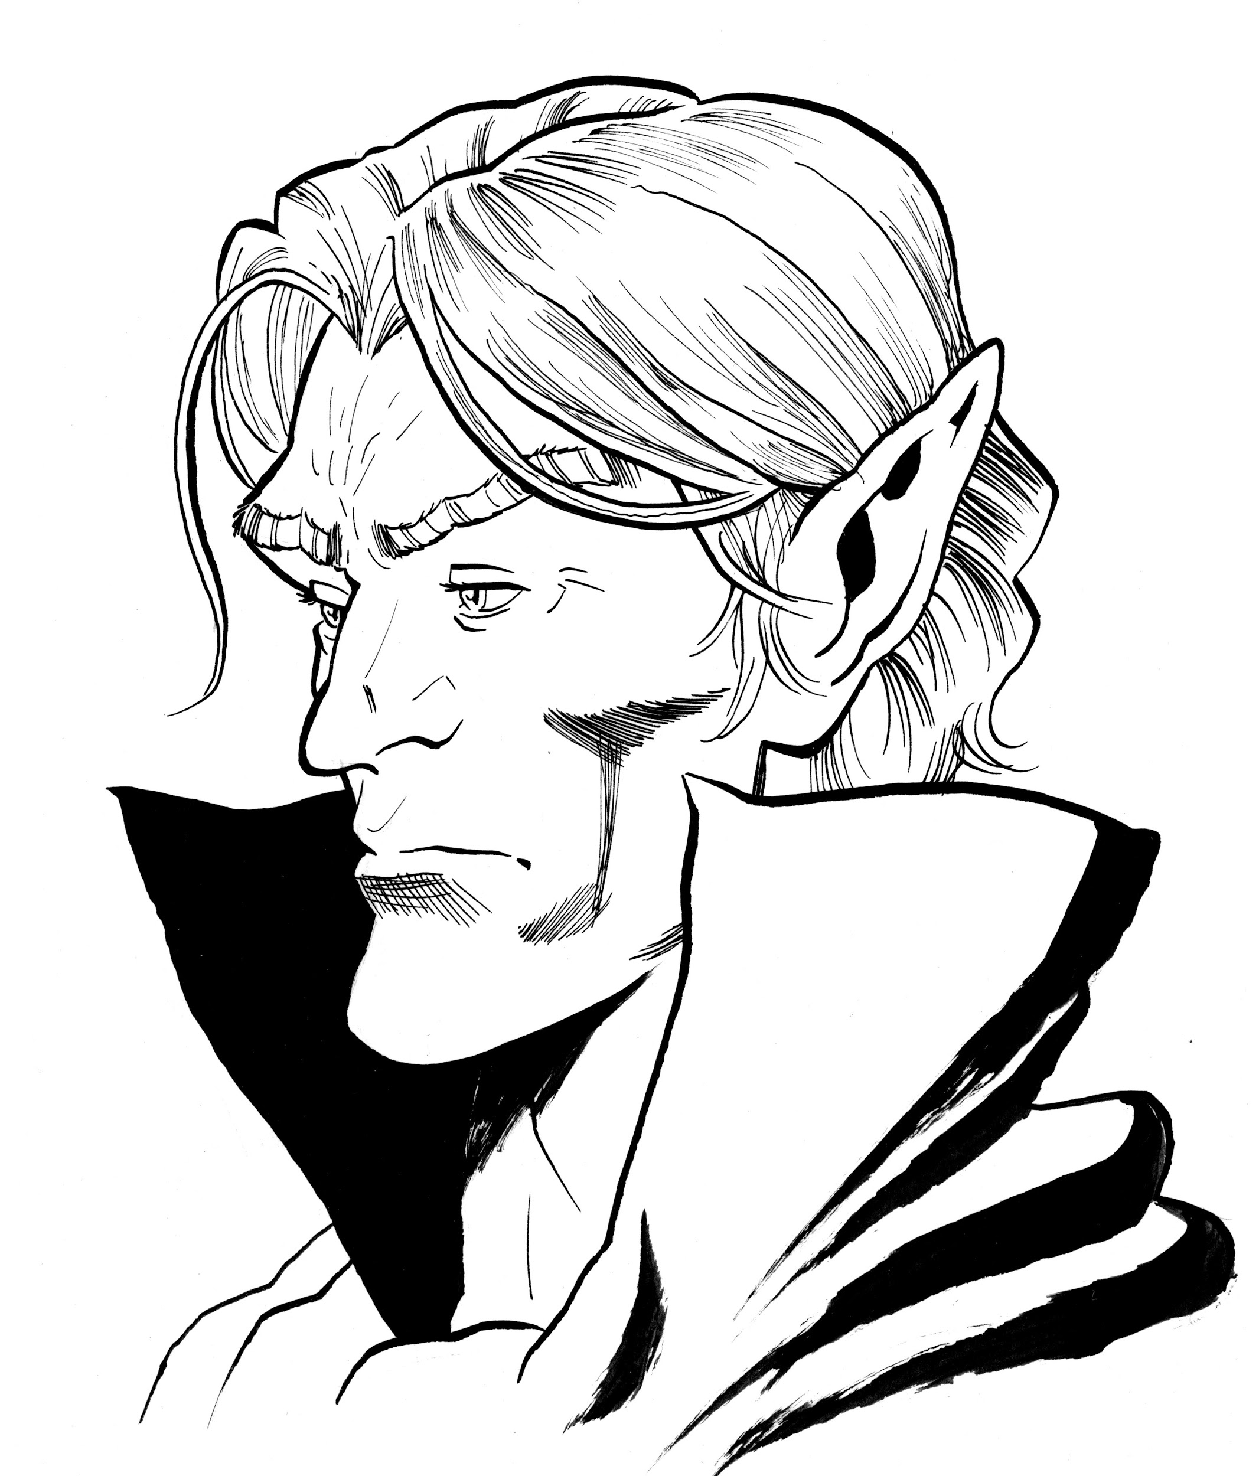

Soluun Xibrindas
Soluun is one of Jarlaxle Baenre’s three lieutenants within the Bregan D’aerthe faction. By far he is the most fanatical and chaotic follower; however, that never impeded him from following Jarlaxle’s commands to the letter by any means necessary. Soluun has proven himself to go above and beyond again and again; when told to eliminate enemies of Bregan D’aerthe, he not only did it swiftly but ensured that they suffered.
He joined Bregan D’aerthe with his brother, Nar’l, after their entire house was wiped out. Both brothers have proven themselves to Jarlaxle, Nar’l by infiltrating the Xanathar’s guild and Soluun with his unwavering loyalty. However, Soluun looks down upon his brother’s study of magic, considering it a weakness that he would never debase himself to.
Being raised in a drow house within the Underdark forced certain teachings upon Soluun, one being a burning hatred for all surface elves. He takes any available opportunity to kill them, but never out in the open. Soluun is sadistic enough to enjoy a slow hunt, truly a despicable character with few redeeming qualities. He wears fine silk clothes often in dark greys or deep blues, occasionally with his scimitar and dagger in prominent display.

Personality Trait: Bully. The world is a hierarchy, those above us stomp down, we may as well find enjoyment in stepping on those below us.
Ideal: Power. One day, I’ll be able to freely take all that I desire, all that I deserve.
Bond: Bregan D’aerthe. I am fiercely loyal to Jarlaxle, our unquestionable leader.
Flaw: Surface Elf-Hatred. They think they’re better than us drow, I’ll prove them wrong.

Relationship to Volo
Soluun had a passing awareness of Volo, but never had an active interest in any of his work. However, Soluun became obsessed with Volo when rumours began to speculate that the author had made a passing comment about Jarlaxle. The comment in question was far from complimentary.
Knowing Jarlaxle as well as he does, Soluun would just as quickly kill someone in public for an insult rather than stand idle. So, being the fanatic follower that Soluun is, he’s made the choice to watch Volo closely and, should the opportunity present itself, kill Volo. He has yet to tell Jarlaxle, who actually disapproves of killing Volo but admires the effort nonetheless.

d100 | Soluun’s Location
01-60 | The library (area S8) idly flicking through Volo’s most recent book, scoffing occasionally.
61-90 | The ballroom (area S5), where he’ll be intently watching a lone half-elf. His face is the embodiment of hatred.
91-00 | The banquet hall (area S6) sat at a table by himself, eating contently while sending compliments to the chef.

After Volo’s Death
Upon discovering that everyone is stranded within the Ethereal Plane, Soluun is understandably upset. He had matters of the Bregan D’aerthe to tend to, and being trapped in another plane of existence somewhat hinders that. He refuses to be questioned by the adventurers, saying how it is none of their business. However, if Soluun is not the killer, he makes his enjoyment of Volo’s death clear.

His Account of Events
Soluun’s description of events is blunt. He says he did not see Volo get murdered, but wishes he had. Instead, he was spending his time keeping out of the light, as drow are known to do. However, if pushed for an answer, Soluun does everything to hint that a surface elf - such as Davil Starsong, within the adventurers or, at the party - has snuck behind everyone’s backs to kill Volo, scowling all the while he speaks.

If He Killed Volo
When: During the Behind My Back encounter.
How: Grabbing Volo and cutting out his tongue, slashing him with a scimitar, and shooting him with a poisonous pistol.
Why: Soluun heard that Volo made a passing but insulting comment about his leader, Jarlaxle. Soluun believes that cannot go unpunished.
Fake Alibi: While conducting the murder, Soluun disguised himself as Jarlaxle, wishing to give him the credit for killing Volo but inadvertently incriminating him.

Murder Clue | Description | Encounter & Location
Volo’s Body | Volo’s body lays within the centre of the room with blackened veins. There are multiple slashes across his body, in combination with a single gut-shot wound and a severed tongue. A successful DC 15 Intelligence (Investigation) deduces that the slashes came from a curved blade of sorts, and the gunshot wound was dealt at point-blank range.  Inspecting the blackened veins, a successful DC 15 Wisdom (Medicine) check reveals that Volo was poisoned, just before he died. | Hawk’s Eye Balcony (area S11)
Speak with Dead | If asked, Volo believes he identified his murderer as Jarlaxle. However, before he was killed Volo managed to see that it was some form of magical disguise but not who was behind it. To Volo’s knowledge he’s never said anything particularly negative about Jarlaxle. His death was far from pleasant; his killer tried their best to torment him. | Hawk’s Eye Balcony (area S11)
Wall Marks | The walls around the room have specks of blood scattered across them. Upon closer inspection, like a successful DC 14 Wisdom (Perception) discovers the remains of a bullet embedded within the wall. | Hawk’s Eye Balcony (area S11)
Smokepowder Residue | Within the room, any character who attempts to smell the air discovers, on a successful DC 17 Wisdom (Perception) check the distinct scent of smokepowder. Any characters that have used a pistol before have advantage on the check. | Hawk’s Eye Balcony (area S11)
Faint Bang Heard | At the time of Volo’s death, those within the foyer or spiral staircase with a passive (Wisdom) Perception of 20 or higher hear bang from the very top of the statue. A few patrons confirm that they, too, heard a bang from upstairs, before everything was shifted into the Ethereal Plane. | Foyer (area S3)
Imitation Jarlaxle Hat | Snuck into the kitchen by Soluun, to be placed atop the apron rack that hangs on the wall. Only Wehltrin, the head chef, identifies it as not belonging within their kitchen. However, they also know it bears some resemblance to a hat worn by an infamous Waterdhavian drow. In truth, the hat is a hat of disguise (see appendix A) allowing its wearer to briefly appear as someone else.  If the hat is lifted, it lights a fuse which ignites the smokepowder. Each creature within 20 feet must succeed on a DC 12 Dexterity saving throw or suffer 3d6 fire damage, or half as much on a success. | An Explosive Distraction  Kitchen (area S6)
Frug Knucklespring | At the start of the evening Frug stopped Soluun from entering, despite his invitation, because he openly possessed a blade. Annoyed, Soluun eventually relinquished possession of his scimitar, which he later stole back, as witnessed by Davil. | Security Concerns  Foyer (area S3)
Missing Scimitar | Within the entry hall is a locked crate for confiscated weapons. Soluun’s scimitar was placed in there by Frug but is now missing. Soluun currently has it concealed within a compartment of his studded leather tunic. A successful DC 18 Intelligence (Investigation) check reveals that it could have been the murder weapon, but the blade is clean of all blood. | Stealing Whats Mine  Entry Hall (area S2)
Volo’s Tongue | Wishing to present Jarlaxle with evidence of his work, along with the sentiment that those who speak poorly of the Bregan D’aerthe shouldn’t speak at all, he’s kept it securely within a tightly-sealed thick leather pouch. | In Soluun’s possession.

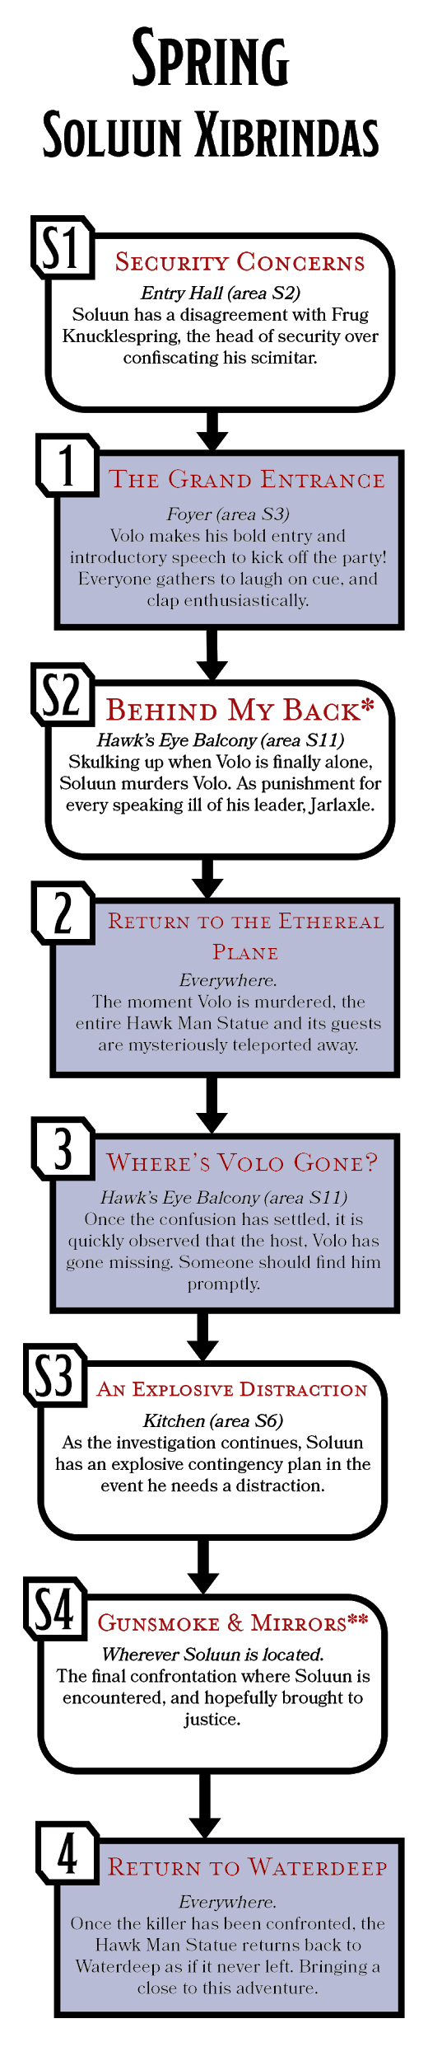

Soluun’s Encounters
A fiercely loyal bully, Soluun attends the party in order to defend the honor of his boss, Jarlaxle. He’s a skulking and calculating individual, but his devotion to his leader may inadvertently bring about his eventual incarceration. The encounter marked with a * indicates this is the encounter where Volo is killed, whereas the one marked with ** are when Soluun is finally confronted. In order to maintain the mystery, it is recommended that the encounter with a * happens out of the character’s sight.

S1. Security Concerns
Location: Entry Hall (area S2)
Shortly after the characters arrive at the party, there is a commotion behind them. Frug Knucklespring is arguing with Soluun over confiscating the scimitar he proudly has on display. Any character attempting to overhear the dispute requires a successful DC 16 Wisdom (Perception) check, overhear Soluun attempting most forms of persuasion, bribery, and a veiled threat to no avail. When threatened to be removed from the party, Soluun hands over his scimitar before storming past.
A successful DC 16 Wisdom (Insight) check reveals that Soluun is suppressing his rage, eyes set straight ahead with fury in his walk. Soluun later returns to steal back his scimitar, as witnessed by Davil Starsong within the optional “Stealing What’s Mine” encounter.

S2. Behind My Back*
Location: Hawk’s Eye Balcony (area S11)
Soluun subtly skulked Volo throughout the party. When he saw Volo move off alone, Soluun was close behind. He did not waste any time, stepping right up and shooting Volo in the gut, before proceeding to slash him repeatedly with his scimitar. Soluun had donned the hat of disguise, pretending to appear as Jarlaxle to continually reprimand Volo for ever insulting them.
Before Volo died, Soluun cut out Volo’s tongue as evidence of his handiwork. Removing his hat and stuffing it full of smokepowder as a boobytrap, Soluun snuck away from the balcony to place the hat into the kitchen (area S6). From start to finish, Soluun worked within a minute, doing everything to maximise Volo’s suffering in that short period.

S3. An Explosive Distraction
Location: Kitchen (area S6)
As a precaution, Soluun stashed his hat of disguise within the kitchen stuffed with smokepowder. If the hat is disturbed, or Soluun speaks a command word it’ll ignite the fuse causing an explosive distraction. This is something Soluun will use if he believes he is being followed, or if the heroes begin to interrogate him. In response, he’ll break line of sight to speak the command word to cause havoc on the lower floors.
The explosion causes significant damage to the kitchen, killing many of the servants or chefs involved. A successful DC 15 Intelligence (Investigation) determines the explosion originated from the coat rack. Frug Knucklespring is quick to arrive at the scene, who shares what information he knows with the party;
- Frug informs the party of his encounter with Soluun about confiscating his scimitar, and when Frug recently went to check, the scimitar was missing.
- One or two guests report spotting a drow walk in and out of the kitchen, this could’ve been Soluun or Wehltrin Do'ervs, who works as head-chef.
- The hat of disguise was damaged in the explosion, but survived enough to still bear the resemblance to Jarlaxle’s hat.

S4. Gunsmoke & Mirrors**
Location: Wherever Soluun is located.
Soluun remains resistant to any interrogation or line of questioning, but he is always aware when tones begin to become accusations. He makes sure to inform the party that he has connections to individuals they should not wish to cross. But ultimately, Soluun would not let the party make the first move, if he had been found out, Soluun would begin to hunt the characters instead.
Tactics. Soluun cannot help but prey on the weakest, using darkness to initiate the fight and his boots of elvenkind to move entirely undetected. He is very likely to be outnumbered, so at any given opportunity he breaks line of sight, firing his poison pistol to harm attackers. As the situation turns dire, Soluun may resort to throwing ignited bags of smokepowder. However the fight goes, Soluun does not relent nor does he surrender. He would sooner die than let himself be captured and disgrace Jarlaxle.

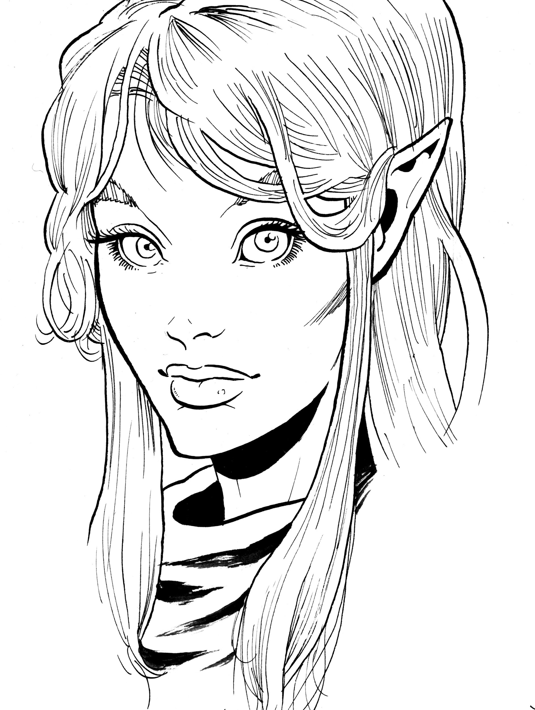

Pirene, the half-nymph
Pirene is a warm candle on a winter's evening, a crackling bonfire in a summer’s midnight. From the outside she may seem like a half-elf, but her soft voice and enticing eyes hint at her fey heritage. To say that Pirene is beautiful would be an understatement, but it is her gaze, rather than her appearance, that draws one’s attention. A knowing behind the eyes, and yet there is a deep burning within them that when viewed in one light can be an unyielding passion, and another an unquenchable anger.
The origin of Pirene is an unfortunate tale of countless misunderstandings. Her reclusive mother, Felerua, a true nymph, lived deep within an ancient forest beside a tranquil pond. Volo, during his brief escapade in writing the Complete Guide to the Behavior of Nymphs, accidently stumbled into Felerua’s domain.
Felerua was initially enraged by Volo, tempted to use her charm to drive him insane and leave him for dead. But when the two spoke, Felerua was disarmed by her curiosity due to a shared interest of truth and discovery. Moment by moment tensions lowered. Minutes turned to hours, and they spoke and laughed from dusk till dawn. The two quickly grew intimate and fell asleep in each other’s arms. Volo was the first to awake, victim to his body’s call for nature. He carefully stepped out into the forest, trying to find a suitable location. Unfortunately for Volo, his paths crossed with a lone but extremely territorial owlbear; one thump later, he was left unconscious.
When Volo awoke, bleary eyed, he believed all the events of the night before to be the effects of a nymph's allure. Considering himself incredibly fortunate to still be alive, Volo hastily returned to civilisation. He went on to proudly boast how he survived an encounter with a nymph. Felerua, however, waited a single day and night for Volo’s return. When Volo never returned, she found herself briefly brokenhearted but discovered an invigorated resolve. She had fooled herself, and while reminders of Volo’s perceived trickery still ached, Felerua had a more urgent matter to tend to - the child she was bearing.
Felerua did her best to raise Pirene, frequently instilling the lesson of never trusting a sweet-talking human. Over time, Pirene could see the pain this “Volo” had caused her mother. Pirene made a simple vow: since Volo broke her mother's heart, she would rip his out by force.

Personality Trait: Center of Attention. Moonlight does not glimmer for the flora or fauna, it simply does, much like me.
Ideal: Love. Mother spoke like leaves on water, but she loved as deep as an ocean stone.
Bond: Family. We may forge friendships and make enemies, but the blood in my veins is always that of my kin.
Flaw: Fae-Temper. The fiercest of storms often gives no warnings.

Relationship to Volo
Pirene’s relationship to Volo is an understandably complicated one, given that she is his estranged daughter. Prior to the release party, Pirene had never met nor spoke to Volo. She knew of him as a result of years of tracking him, reading his books, and speaking to anyone who had met him. Her quest has been one fueled by rage and spite, to discover everything about the man who broke her mother’s heart.

d100 | Pirene’s Location
01-60 | The ballroom (area S5), dancing away wildly or waiting impatiently for the music to begin.
61-90 | The library (area S8), angrily flipping through Volo’s latest book.
91-00 | The smoking room (area S7), flirting openly with a finely dressed female tiefling.

After Volo’s Death
Following the Return to the Ethereal Plane event. Pirene does little to hide her pleasure at discovering Volo’s death. She vows she didn’t kill him, but she wishes she had. Pirene’s location can be determined using the corresponding location table. She doesn’t mind speaking with the characters, but would prefer the music continue so that they all may dance.

Her Account of Events
Pirene arrived at the party early, hoping to speak with Volo before everything started. After being unable to find him, she went into the ballroom to chat idly with the musicians. Once the party started and Volo made his speech, Pirene ran directly to speak with him. Unfortunately she clashed with Hailee Dunn; and after escaping the argument she found Volo. The two then engaged in a heated discussion, in which she revealed that she is his estranged daughter. They were interrupted by Davil Starsong. She then spent the remainder of the evening with a fellow guest Lady Visamel Opal, within eyesight of a Sparaunt guard, Hannar Bright.

If She Killed Volo
When: During the Daughters’s Scorn encounter.
How: Being stabbed in the heart from behind. His heart was later torn from his chest.
Why: Avenging the way she believed Volo had treated her mother. She believes he tricked her mother, abandoning her with a broken heart.
Fake Alibi: Using her nymph heritage, Pirene has charmed two individuals. Another party guest and a Sparaunt Guard both attest to her being downstairs during the time of the murder.

Murder Clue | Description | Encounter & Location
Volo’s Body | Volo lays on his side in the middle of the floor, blood scattered across the floor. A hole in his chest reveals that his heart has been torn out. A successful DC 15 Intelligence (Investigation) reveals that Volo had been stabbed in the heart from behind, and the body has been significantly moved about. | Hawk’s Eye Balcony (area S11)
Speak With Dead | If any of the characters cast speak with dead, Volo knows the following information:  - He was stabbed from behind and didn’t see who could’ve done it.  - He had an argument with a woman claiming to be his daughter.  - Davil Starsong led him up here to discuss a business opportunity that Volo flat-out refused. | Hawk’s Eye Balcony (area S11)
Nymph Hair Braid | - Forced into Volo’s dead grasp is a two-inch long braid.  - Characters who smell the braid must succeed a DC 14 Constitution saving throw or become charmed by Pirene for 1 hour. She, however, will not know that they are charmed.  - A successful DC 20 Intelligence (Nature) check reveals that the braid is from a fey creature, most likely a nymph.  - The braid belongs to Pirene’s mother, and if presented with it a successful DC 20 Wisdom (Insight) reveals that she is trying to conceal that she knows something about the braid. | Hawk’s Eye Balcony (area S11)
Bloody Handprint & Trail | The faintest trail of blood leads from the balcony down towards the library. It takes a successful DC 19 Wisdom (Perception) check to identify the trail against the vibrantly dyed rug. On a pillar outside of the library, a successful DC 16 Intelligence (Investigation) reveals a half-handprint where someone seemingly briefly leaned up against the wall. | Library (area S8)
Bloody Glove | In one of the far corners, a bloody glove has been hidden behind some older books on the bottom of a shelf. The dust around them has been distrubed, indicating recent movement. | Library (area S8)
Sparaunt Guard Dagger | Under the desk within the centre of the room, a guard’s dagger has been stabbed into the wood. The blade is clean, but a successful DC 15 Intelligence (Investigation) check reveals it was recently covered in blood. | Library (area S8)
Sparaunt Guard | Hannar Bright has been working for Lady Sparaunt for a few years. She’s reliable and sturdy. She’s currently charmed by Pirene, and the dagger which all guards have on their belt is missing. | Accompanying Pirene
Party Guest | Lady Visamel Opal, a noble within Waterdeep, is known for her association with the Talmost family. She, too, has been charmed by Pirene. Her attire appears to be missing both fine, elbow-length white gloves. A successful DC 16 Wisdom (Insight) check reveals that Visamel is visibly uncomfortable without her gloves, unsure where to place her hands. | Accompanying Pirene
Volo’s Heart | Deep within a hidden leather pouch, Pirene keeps Volo’s pierced heart. It has dried somewhat, but the inside of the bag is damp with blood. | In Pirene’s possession.

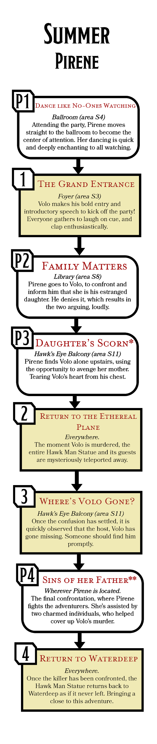

Pirene’s Encounters
Despite her intentions to kill Volo, being among civilisation is rare for Pirene, and it is an opportunity she wishes to make the most of. However, these attributes eventually lead to her downfall. The encounter marked with a * indicate this is the encounter where Volo is killed, whereas the one marked with ** is when Pirene is finally confronted. In order to maintain the mystery, it is recommended that the encounter with a * happens out of the character’s sight.

P1. Dance like No One’s Watching
Location: Ballroom (area S4)
Before Volo even appears to give his opening speech, and partially during, Pirene swirls and dances within the very heart of the ballroom. Guests, guards, and the musicians seem entirely enraptured by her performance. Characters watching need to succeed a DC 12 Wisdom saving throw, otherwise they’ll feel compelled to join in the dance. A subsequent successful DC 18 Intelligence (Arcana) discerns that there is something clearly fey about Pirene. Pirene invites multiple people in, all the while never breaking her motions.
Alternatively, if Pirene is left alone with a character, she might see it as a perfect opportunity to charm a member of the party. If they succeed the save, Pirene would apologise deeply, and blame it on an inability to control parts of her fey heritage. A successful contest of Pirene’s Charisma (Deception) against the characters Wisdom (Insight) reveals that she is telling a half-truth but did not mean the character harm.

P2. Family Matters
Location: Library (area S8)
As characters approach the library, they observe that the door is closed and a muffled yelling is heard from inside. A successful DC 16 Wisdom (Perception) check to listen closely reveals that Volo is having a heated argument with a female voice. If the check is passed by 4 or more, they distinctly make out the word “daughter” said repeatedly.
Before much else can happen, the yelling grows louder as it approaches the door which suddenly swings open. Pirene pushes past the group to return to the ballroom (area S4), leaving Volo standing alone looking flabbergasted among stacks of his new books. A successful DC 12 Wisdom (Insight) check reveals that Pirene is furious. Volo is hesitant to share any information regarding the argument, dismissing it quickly as insane. He does ask however for the adventurers to go and enjoy the party, while he takes some time to think alone on the balcony (area S11).

P3. Daughter’s Scorn*
Location: Hawk’s Eye Balcony (area S11)
Following the unsuccessful conversation with her father, Pirene simply waits. She charms both a noble, Lady Visamel Opal and a guard, Hannar Bright, to assist with her plans. Pirene asks Hannar Bright to ensure she is not interrupted, while taking one of Lady Visamel’s gloves and Hannar’s dagger.
Sneaking up to the balcony, Pirene catches Volo unaware and stabs him repeatedly in the back. Watching the life drain from Volo, she takes out a lock of her mother’s hair and forces it into the corpse’s grasp. Content with her work, Pirene returns the bloody glove back to Lady Visamel, who in a panic proceeds to hide it within the library (area S8). Pirene follows, opting to conceal the murder weapon under the desk but jabbing it into the wood underneath.

P4. Sins of her Father**
Location: Wherever Pirene is Located.
After Volo has been killed, Pirene never leaves the company of her two charmed allies and is found using the Pirene’s Location table. While they talk, she aims to direct any accusations towards the other two, or interject when they are being interrogated. When it becomes clear that the characters believe Pirene to be the culprit, she curses Volo for ever being her father, and engages the characters in combat.
Tactics. Pirene uses any charmed individual to aid her, Lady Visamel (commoner) stays out of combat, other than throwing hazards to slow the adventurers. Each hazard requires a successful DC 10 Dexterity saving throw to navigate past, failing results in being knocked prone. Hannar Bright (guard) is more confident, and putting herself near Pirene to protect her doesn’t feel like a dangerous act.
Pirene can be particularly cruel, singling out an individual to ensure that they suffer, such as someone who spoke positively about Volo within her presence or bears any resemblance to him.

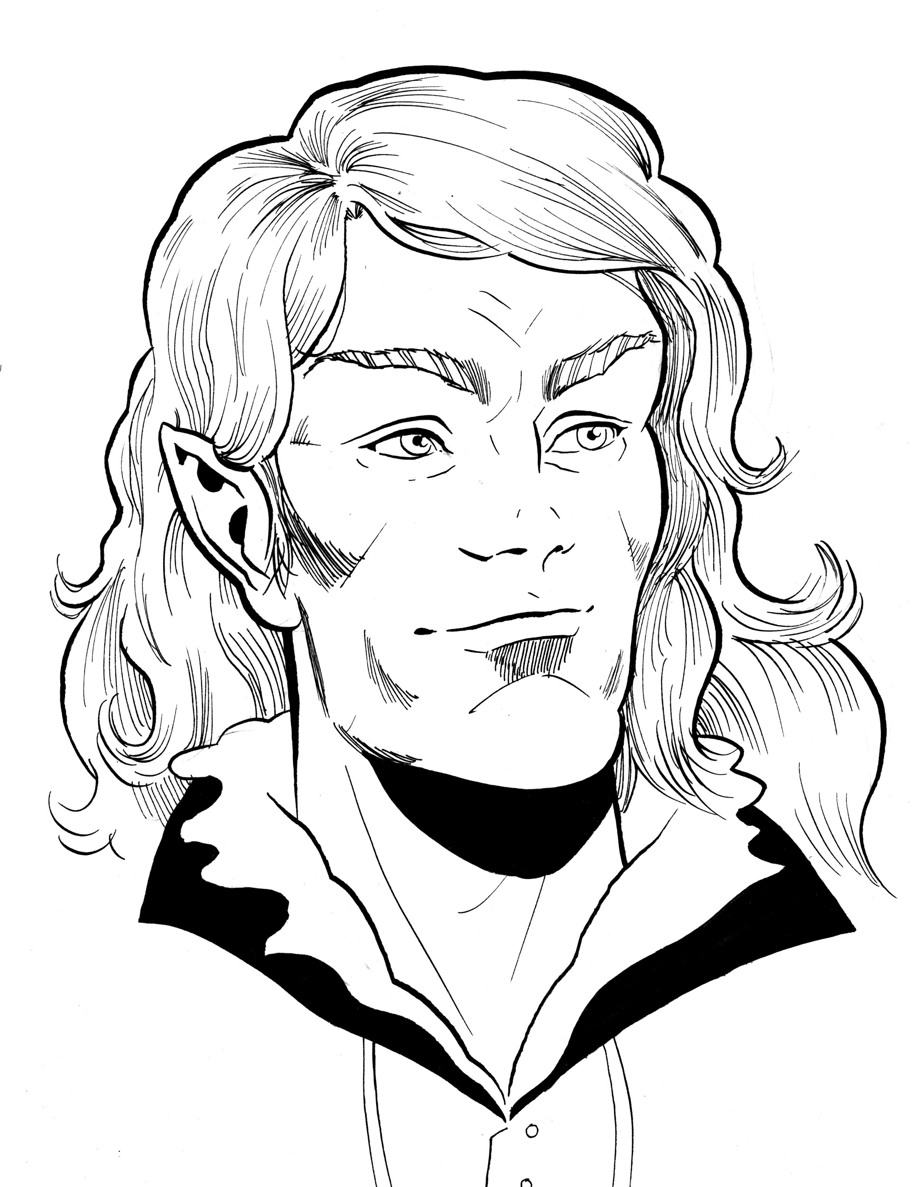

Davil Starsong
Davil Starsong acts as the Master of Opportunities and Negotiations for Waterdeep’s own division of the Black Network, or as they are better known, the Zhentarim. He’s a fairly attractive sun elf, often caught in vibrant blues with yellow or gold stripes, with a finely crafted elven lute slung over his shoulder.
Davil shares a number of similarities to Volo. First, he is something of a smooth talker, as would be expected from his role. Secondly, Davil also has an affinity for magic.
In his youth (not that Davil is particularly old) he was part of a legendary adventuring company known as the Doom Raiders. They dove straight into the heart of danger with lich’s lairs as their prime target. The company’s idea of retirement led them to the Zhentarim, because working from Waterdeep seemed significantly more appealing than clearing out any more lich lairs, or as they’re known, “dooms,” hence the adventuring company’s name.
It was under the order of the Black Network that Davil and the rest of the Doom Raiders moved to Waterdeep to establish a foothold. The pay was good. Davil acted as a middle-man in securing profitable loans, magic, and mercenary work from the Zhentarim for acquaintances.
His reputation with the Black Network recently took a slight hit, as he was briefly imprisoned by the City Watch following the events of the Gralhund Villa Bloodbath. Davil fears little, but the thought of falling out of favour with the Black Network and being forced out of Waterdeep is something he’ll fight tooth and nail to avoid.

Personality Trait: Negotiator. If someone disagrees with me, I take it upon myself to convince them to see my side.
Ideal: Fortune. Opportunities for lucrative deals are easily found, if you’ve got the eye for it.
Bond: Black Network. Years of delving into dooms make me appreciate what we have in Waterdeep.
Flaw: Drinker. Once I start to drink, I find it hard to stop - not that it interferes with my work much.

Relationship to Volo
Davil occasionally meets up with his fellow Doom Raiders at the Yawning Portal, where he has made contact with Volo on a number of occasions. Given Davil’s ability to make friends quickly, he and Volo have the appearance of being rather friendly. By Davil’s own admission, he’s attempted to create a lucrative business deal with Volo multiple times, but each time he has been rudely dismissed by the explorer.

d100 | Davil’s Location
01-60 | The banquet Hall (area S5), mingling with a drink in hand.
61-90 | The smoking room (area S7), leaning heavily against the bar.
91-00 | The foyer (area S3), standing with an empty wine glass.

After Volo’s Death
Following the Return to the Ethereal Plane event. Davil’s location can be determined by using the corresponding location table. He is happy to be interviewed by the characters, assuming they’re not accusing him; however, he is more focused on returning back to the Material Plane.

His Account of Events
Davil explains that he arrived late. Witnessing a drow (Soluun) steal a scimitar from a crate within the entry hall. Davil pushed pass to immediately seek Volo out, mostly to apologise for his late arrival and discuss a private business opportunity. He found Volo arguing rather loudly with Pirene and interrupted to give Volo an excuse to escape. He then led Volo upstairs to the Hawk’s Eye Balcony for a private word, leaving him to think before appearing in the Banquet Hall to mingle for the rest of the evening.

If He Killed Volo
When: During the Eyes of a Hawk* encounter.
How: Davil had his companion, Ziraj the Hunter, fire a poison dipped, drow-dagger-tipped arrow through the eye of the Hawk Man statue. The arrow hit Volo in his heart, killing him almost instantly.
Why: Davil was in charge of organising the abduction of Renaer Neverwinter, but instead caught Volo’s friend Floon in a misidentification. Volo’s interference led to both Floon and Renaer escaping, which only displeased the Zhentarium. In order to avoid such issues again, Davil gave Volo a choice: leave the city immediately or die. Volo opted for the latter.
Fake Alibi: Davil left Volo alone in the Hawk’s Eye Balcony to consider a business opportunity.

Murder Clue | Description | Encounter & Location
Volo’s Body | In the center of the balcony, Volo lays lifeless on his back. An onyx dagger protrudes from his chest. A pinkish liquid covers his face, and his mouth is missing; where it should be is mysteriously sealed shut. | Hawk’s Eye Balcony (area S11)
Suspicious Pinkish Liquid | - The liquid is a potion of flesh shape (see appendix A), a vial of Skeemo Weirdbottle’s creation.  - A successful DC 14 Intelligence (Arcana) check reveals that the liquid is magical in nature, belonging to the school of necromancy. | Hawk’s Eye Balcony (area S11)
Broken Window & Arrow Shaft | Shattered glass surrounds the floor of the right port window. A successful DC 12 Intelligence (Investigation) check deduces that something smashed through the window, rather than out of it. Peering out of the window and looking down, a character that succeeds on a DC 17 Wisdom (Perception) check notices an arrow shaft and tail, resting within a crack of the statue’s face, down roughly 10-feet. | Hawk’s Eye Balcony (area S11)
Drow Dagger | - Inspecting the onyx dagger, a successful DC 14 Intelligence (Religion) check reveals that the dagger holds depictions of the goddess of spiders, Lolth.  - A successful DC 15 Wisdom (Medicine) check on the wound caused by the dagger reveals that it was thrust into Volo with considerable force. | Hawk’s Eye Balcony (area S11)
Dent in the Wall | - A number of small dents are in the far wall behind Volo’s body. They appear to be at least a few days old. A successful DC 17 Intelligence (Investigation) check identifies that the dents line up from the window straight through where Volo must’ve stood.  - The dents were caused by Ziraj the Hunter, taking some practice shots before the real thing. A Zhentarim agent later collected the arrows to dispose of them. | Hawk’s Eye Balcony (area S11)
Zhentarim Agent | Nursi Goldsteel is working with Davil, acting as his eyes and ears during the party. Once the music stops, she actively follows the party. | Chase the Snake  Ballroom (area s4)
Winged Snake | Nursi Goldsteel’s flying snake has been tasked to deliver the occasional message between her and Davil, implicating the Zhentarim in Volo’s death. | Chase the Snake  Foyer (area S3)
Empty Potion Vial | - If characters have identified the Potion of Flesh Shape, it is easy to deduce that it originated from this vial.  - Any character that has encountered Skeemo Weirdbottle can identify the vial as one of his creations. | In Davil’s possession.
Witness Account | If the characters discover Crill, and prove themselves as allies, Crill eventually shares that he saw Davil standing on a rooftop alongside a burly half-orc wielding a massive bow prior to the party starting. | Eagle Eyed Witness  Sparaunt’s Aviary (area S9)

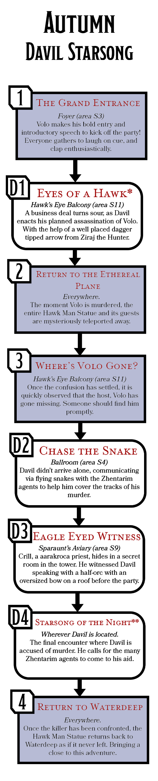

Davil’s Encounters
Davil arrives at the party late, and when he does, it is straight to business. Matters are complicated when he and his Zhentarim associates become trapped in Sparaunt Tower. As Davil and Nursi Goldsteel communicate, they inadvertently leave enough evidence to implicate themselves. The encounter marked with a * indicate this is where Volo is killed, whereas the one marked with ** is when Davil is finally confronted. In order to maintain the mystery, it is recommended that the encounter with a * happens out of the character’s sight.

D1. Eyes of a Hawk*
Location: Hawk’s Eye Balcony (area S11)
Arriving late, Davil finds Volo and asks for a word in private. The pair proceed to the balcony, where nights before Davil planned for Ziraj the Hunter to fire a dagger-tipped arrow through the window. The shot landed true, piercing Volo in the heart and killing him. Davil then quickly discarded the arrow shaft out of the window and used one of Skeemo Weirdbottle’s concoctions to flesh shape Volo’s mouth shut. His entire plan went off without a hitch, at least until the entire statue teleported into the Ethereal Plane.

D2. Chase the Snake
Location: Ballroom (area S4)
Once the party returns downstairs from discovering Volo’s body, characters with a passive Wisdom (Perception) score higher than 17 notice that one of the musicians is watching them closely, so much as to begin following them from a far distance. The musician is Nursi Goldsteel (spy), working for the Zhentarim and Davil. She’ll watch them closely and report to Davil by sending a flying snake with a message.
If the characters fail to spot Nursi’s spying, they hear the faint flapping where a successful DC 13 Wisdom (Perception) check identifies a flying snake hugging the shadows flying from Nursi to wherever Davil is hiding. If the snake is apprehended, the characters discover a hastily written note that outlines whatever the party was just doing.
Confronting Nursi Goldsteel is met with harsh denial. She lies, saying that since Volo was murdered she is suspicious of everyone. The truth can be discerned from a contest of Nursi’s Charisma (Deception) against a character's Wisdom (Insight).

D3. Eagle Eyed Witness
Location: Sparaunt’s Aviary (area S9)
If the characters discover the Sparaunt Tower’s secret room, or need assistance in pinpointing the murderer, they find the deliberately quiet aarcraoka, Crill. He is wary of the adventurers as they have invaded his home, where a successful DC 16 Wisdom (Insight) determines that Crill is studying the group intently as if to evaluate their trustworthiness.
Provided the characters prove they can be trusted, either by having other Sparaunt Tower staff vouch for them or a successful DC 15 Charisma (Persuasion) check, Crill reveals that he saw Davil Starsong standing on a roof nearby the statue with a half-orc bearing an oversized bow mere minutes before the party.

D4. Starsong of the Night**
Location: Wherever Davil is located.
Confronting Davil requires him being found first. His location can be determined using the Davil’s Location table. Davil defuses any accusations, relying on mentioning his Zhentarim connections only if the conversation proceeds to go sour. A successful DC 18 Wisdom (Insight) check reveals he is hiding far more information than he lets on, as well as the incriminating potion vial, hidden on his person. When conflict is inevitable, Davil makes a sharp whistle before engaging in combat.
Tactics. Three Zhentarim spies, disguised as members of the party (one of which will be Nursi Goldsteel unless apprehended), emerge to fight beside Davil. If confident that he has a fighting chance, he’ll open the fight by casting dominate person on the character that poses the largest threat. From there, Davil uses his many allies to keep out of harm's way, supporting them by casting neutralising spells like polymorph or suggestion if his concentration is broken. Once below half his maximum hit points, Davil casts invisibility on himself in order to escape.

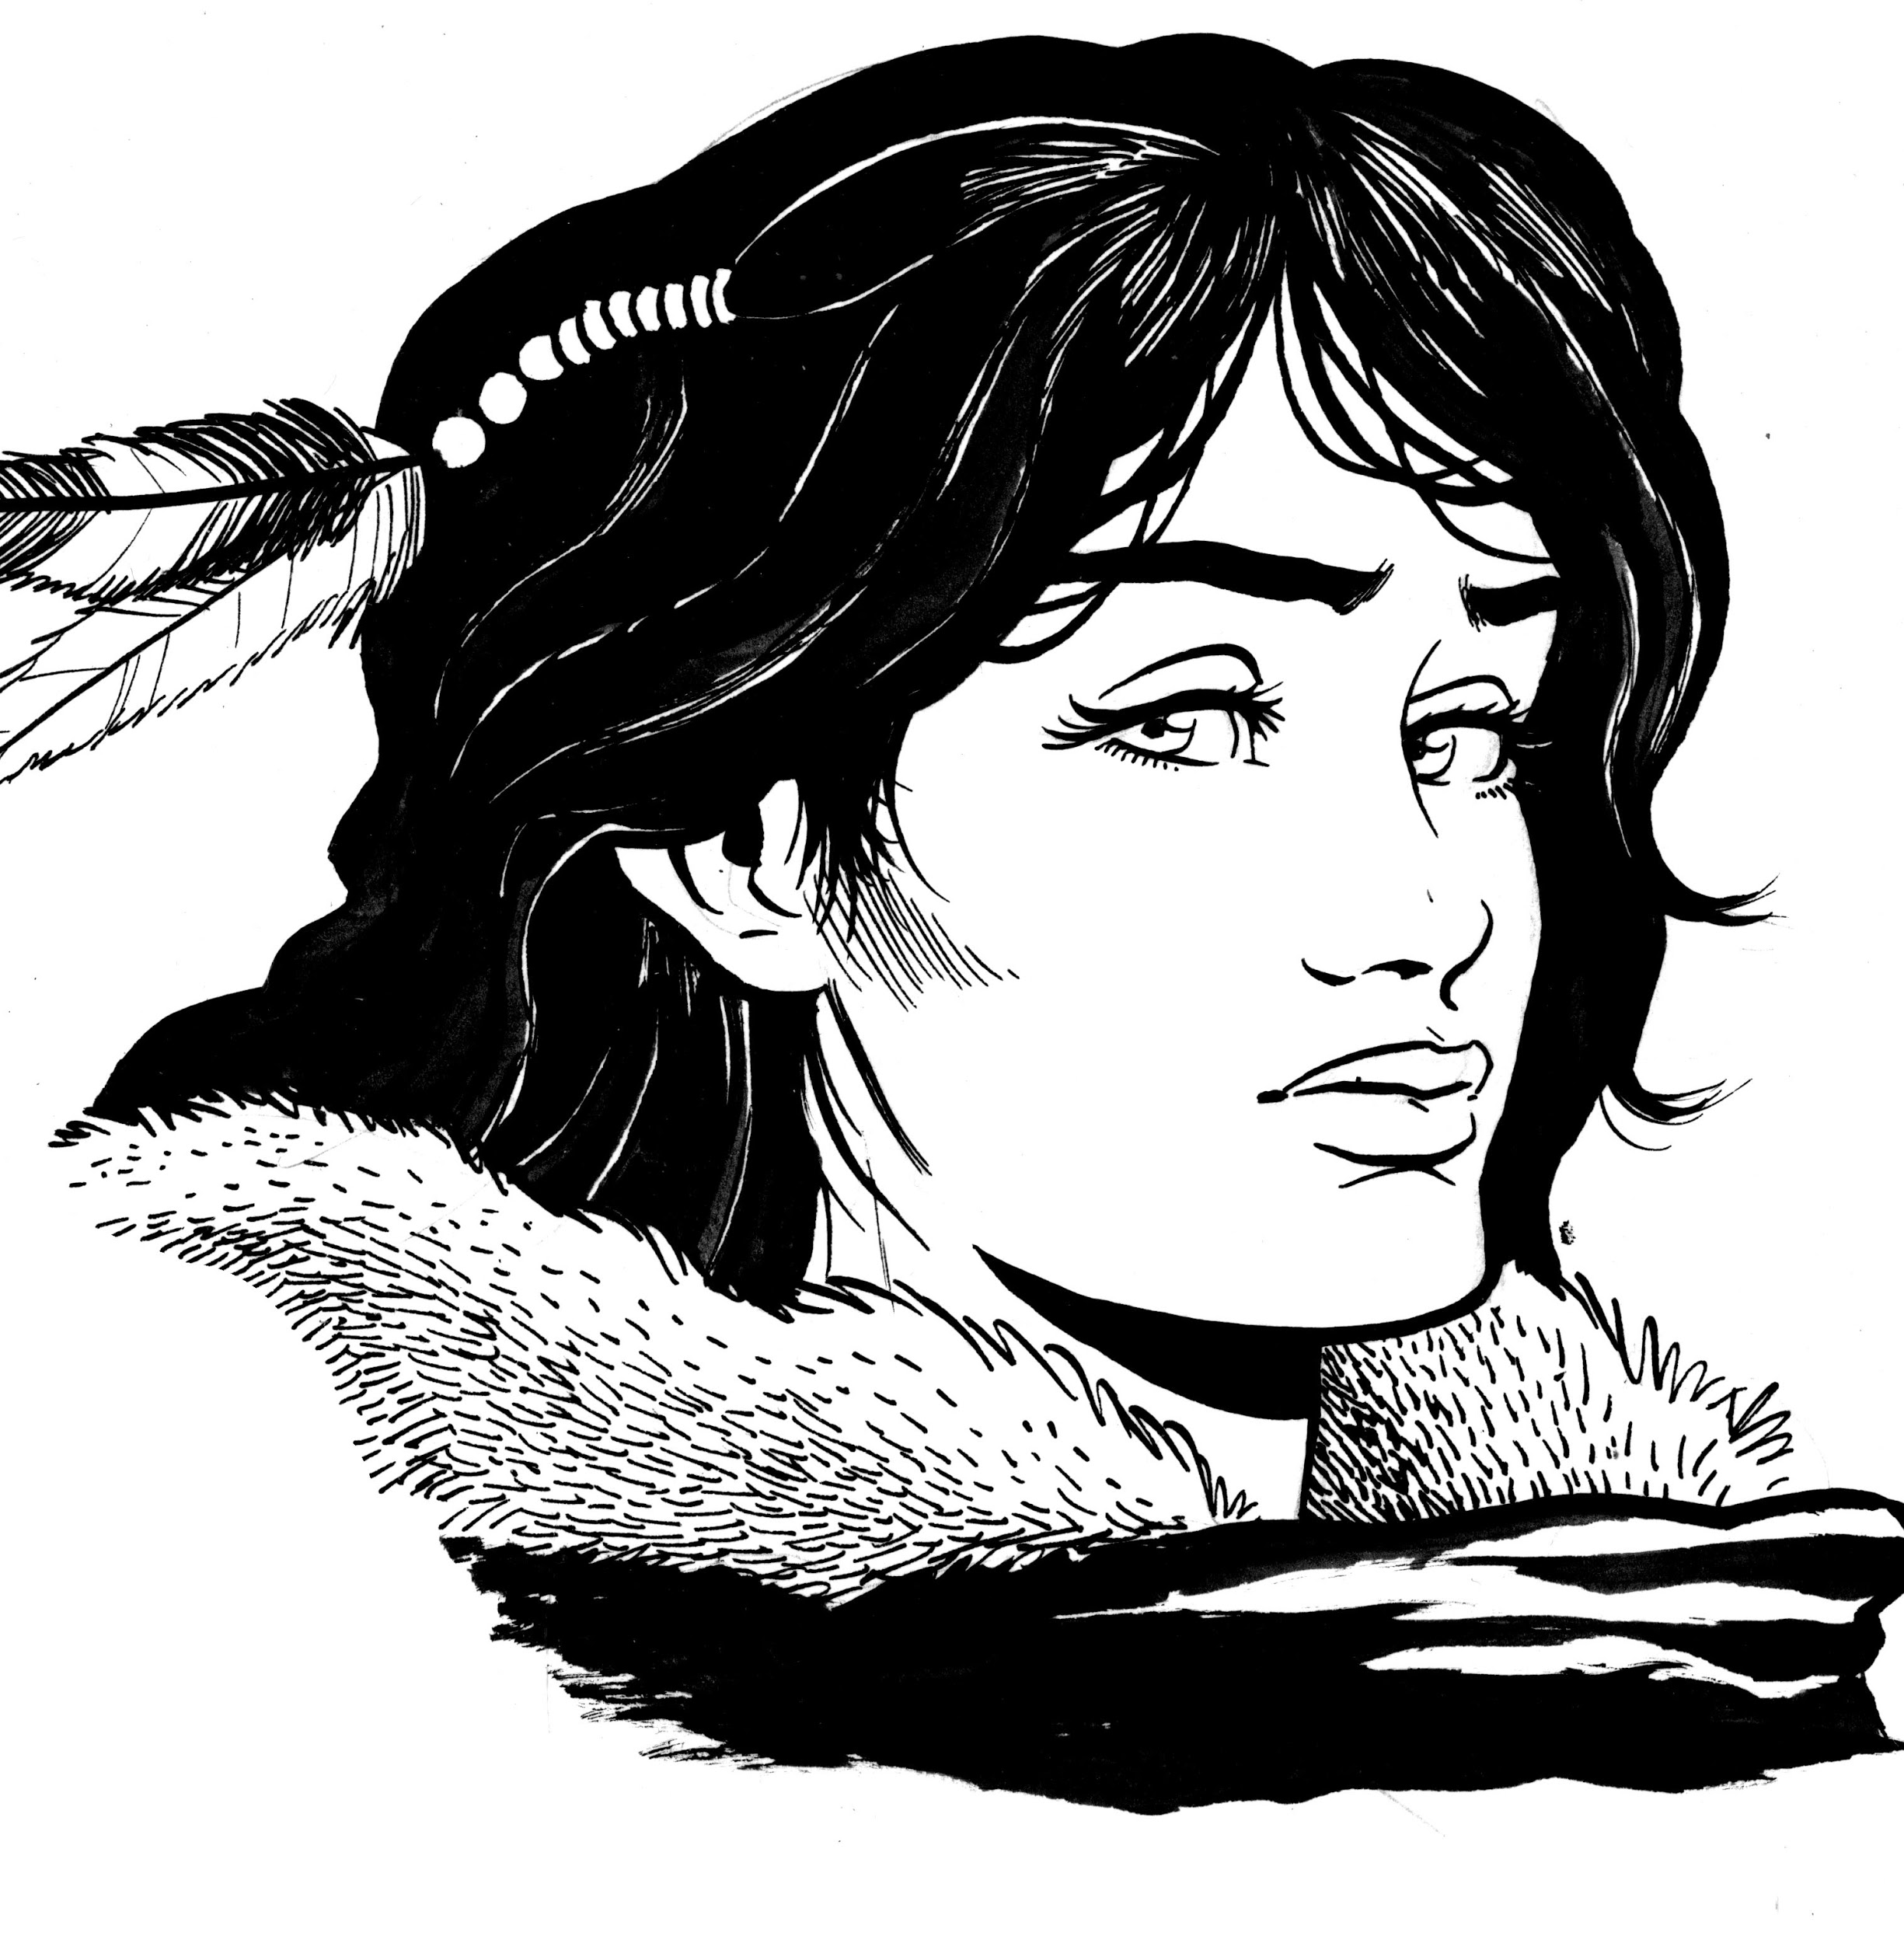

Hailee Dunn
Hailee Dunn is from Lonelywood, one of the Ten Towns in Icewind Dale. It is a cold and unforgiving land, where if the climate doesn’t deter you, the barbarian, goblin, yeti, or orc raids might. As such, she’s a sturdy, broad-shouldered woman. Her dark brown hair is braided and coiled into a bun behind her head. Hailee wears a thick, greying winter cloak filled with many hidden pouches and pockets.
By her own admission, Hailee was a troublesome child. She had a habit of lying to entertain herself, spying on residents of Lonelywood and selling those secrets to anyone who would pay her. Lonelywood gained a reputation for harbouring the many rogues of Icewind Dale. Hailee was well-suited for this thief's landing. As Hailee grew, she found other uses for her natural ability to blend with the shadows.
Hailee’s family, as many were in Lonelywood, were poor. Her father, Tybald, struggled under strict merchant laws, and her mother Ambere spent most of her time drowning in ale at the local tavern. Living in the north hardened Hailee, and scrambling for every coin doubly so. She resorted to a life of petty crime, all in the best interest of Lonelywood, helping businesses through her ill-gotten gains.
As such, Hailee has become fiercely protective of her hometown. She’s seen the struggles of the town rise and fall. In her mind, the thriving of the town has always been directly correlated to the commerce flowing through it, and anything that damages the town’s reputation harms its livelihood. People who meet Hailee initially describe her as friendly and fairly talkative, but for her it is simply a means to get gold, to lure people to pay her for secrets or pick their pockets. Those who truly get to know Hailee call her cold, calculating, and cutthroat.

Personality Trait: Icewind Resolve. The people of Ten Towns suffer daily. Any dangers south are nothing.
Ideal: Commerce. The flow of travellers, trade, and coin, pumps the heart of even the smallest of towns.
Bond: Lonelywood. My home ain’t much, but the people work hard and are kind enough.
Flaw: Greed. There is little I wouldn’t say or do for the right amount of coin.

Relationship to Volo
Volo visited Lonelywood while Hailee was in her late teens, when by her own admission she was something of a trouble maker. When Volo appeared, blustered by the weather, Hailee began to sell him information - some true, some false. Hailee made Volo pay a high price for some of secrets earned by her days of spying. She made quite a tidy profit, and Volo seemed satisfied with the bundles of notes he made.
When Volo eventually left, it wasn’t for a year that word of his publication reached Lonelywood. To say that Volo wrote scathing words about Ten Towns would be an understatement. It didn’t help that Volo had a coin pouch stolen (by Hailee) during his stay. Lonelywood suffered commercially in a particularly harsh winter. Most blamed it on the weather, but Hailee only blamed Volo. He had damaged the reputation of Lonelywood, nearly ruined the lives of its citizens, and he’d pay for it. One way or another.

d100 | Hailee’s Location
01-60 | In the smoking room (area S7), drinking and smoking excessively by the bar.
61-90 | In the ballroom (area S4), around the edges attempting to pickpocket nobles or spread false rumours about Volo.
91-00 | In the library (area S8), looking to steal any books of value.

After Volo’s Death
Once Volo’s body has been discovered and the events of Return to the Ethereal Plane, Hailee appears somewhat panicked. She makes no effort to hide how much she detests the feeling of being trapped. She paces about for a considerable amount of time, before opting to find the smoking room to drown out her worries. Whether sober or drunk, Hailee doesn’t oppose speaking with the characters but charges them silver pieces for any information she knows.

Her Account of Events
Arriving in Waterdeep earlier in the tenday, Hailee pawned some goods in order to get a ticket to the party. She arrived with the bulk of the guests and went to collect some dirt and spread illicit rumours about Volo with the other guests. While making her way into the ballroom, she clashed with an elf-looking woman, who Hailee admits she got a little rough with. After failing to find Volo, Hailee swiped a drink and alleviated a man of his coin purse. Next thing she knew, someone announced that Volo was dead.

If She Killed Volo
When: During the To Break the Ice encounter.
How: While Volo’s back was turned, Hailee used a wand of freezing (see appendix A) to freeze him solid. Then, using her trusty ice pick, she smashed Volo’s body to pieces.
Why: Ten Towns received a significantly negative review in Volo’s Guide to the North that Hailee blames on a significant decrease in the town’s commerce.
Fake Alibi: Hailee admits that she commited a crime: she stole a coin purse from some noble while Volo was allegedly being murdered. She offers up the stolen pouch and makes a half-hearted apology.

Murder Clue | Description | Encounter & Location
Volo’s Body | The most striking thing about Volo’s body is the fact that he has been frozen solid and then smashed. Pieces of Volo lay scattered around the room, the worst offending being his head. Puddles of frozen and defrosting blood scatter the room. Stepping on any of the frozen blood puddles requires a successful DC 10 Dexterity saving throw or the creature is knocked prone. A successful DC 14 Wisdom (Medicine) determines that Volo was instantly frozen and promptly smashed. A successful DC 16 Intelligence (Investigation) deduces that some form of ice-pick was used to smash Volo. | Hawk’s Eye Balcony (area S11)
Volo’s Coin Pouch | Volo’s coin pouch is on the floor at the top of the stairs. The lining on one side has been cut, and its contents have been completely emptied. | Hawk’s Eye Balcony (area S11)
Bloody Message | Beside his body, written in Volo’s blood is the simply chilling message that reads: “Volo condemned us all.” It is clear that the message was written in a hurry. | Hawk’s Eye Balcony (area S11)
Snapped Half of a Wand of Freezing | Underneath Volo’s body is a three-inch-long gnarled stick, with one end splintered and frozen. A successful DC 16 Intelligence (Arcana) check identifies the item as a broken wand, and if the result surpassed 20, the character knows the wand broke after it cast a spell. This would indicate the user was not proficient with magic. | Hawk’s Eye Balcony (area S11)
Frozen Fireplace | In the smoking room, the grand fireplace has been extinguished, replaced with a chunk of ashened but frozen wood. While peering into the fireplace, a successful DC 18 Intelligence (Investigation) deduces that a snapped slender piece of wood tucked within the firewood is out of place. A successful DC 16 Intelligence (Arcana) check reveals that the piece of wood is the other part of the wand of freezing. | Smoking Room (area S7)
Destroyed Volo’s Guide to the North | Between a stack of firewood and a coffee table is a wedged book. The book has been scoured with a dagger, and multiple pages have been torn out, presumably thrown into the fire. A successful DC 17 Intelligence (History) check recalls that Volo’s Guide to the North was fairly successful within the south, but many individuals from the north were angered by Volo’s reviews. | Smoking Room (area S7)
Pickpocketed Nobles | Amidst all the chaos, two nobles announce that their coin pouches have gone missing. One believes they simply misplaced it, while the other believes Hailee to be the culprit.  (Alternatively, they could accuse another guest in order to provide a red-herring within the mystery) | Thief Among Us  Foyer (area S3)
Hailee’s Ice Pick | Concealed within a hidden pouch in her cloak, Hailee holds the murder weapon. If the characters catch Hailee within an hour of the murder, the pick-end is cold to the touch, and have watered-down blood across it. Any character who spends time watching Hailee and succeeds in a DC 20 Wisdom (Insight) determines that she is walking in a manner to keep a shape within her cloak concealed. | In Hailee’s possession.
Volo’s Gold | Hailee’s own coin pouch is stuffed to the brim with a wide variety of coins from across Faerun. Upon closer inspection, a few coins have drops of blood speckled across their surface. | In Hailee’s possession.
Unconscious Guard | As Hailee approached the Hawk’s Eye Balcony, she encountered a lone guard. Not wishing to be spotted, she delivered an almighty blow to the guard and hid his body within the unused apartment. Unfortunately for Hailee, she did not deliver a killing blow. The guard was instead left in an unconscious state. The guard can re-emerge if the investigation remains unsolved, however they cannot provide any details about their attacker, other than that they had a winter’s cloak. | Private Apartment D (area S10)

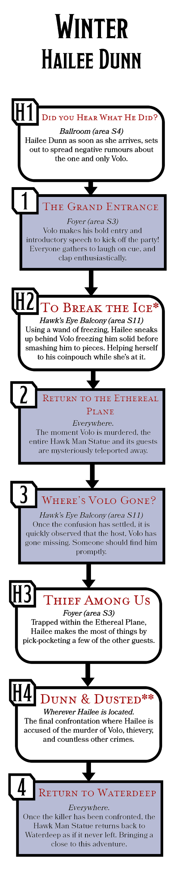

Hailee’s Encounters
Hailee comes to the party with a few intentions, discredit Volo, steal from the rich party goers, and kill Volo. Unfortunately, her kleptomania ultimately contributes to her downfall. The encounter marked with a * indicate this is the encounter where Volo is killed, whereas the one with a ** is when Hailee is finally confronted. In order to maintain the mystery, it is recommended that the encounter with a * happens out of the character’s sight.

H1. Did you Hear What He Did?
Location: Ballroom (area S4)
Before Volo has even made his grand entrance, Hailee Dunn is starting a smear campaign to undermine the guests' opinions of him. As characters enter the ballroom, they can attempt a DC 16 Wisdom (Perception) check to overhear the conversation of some guests. They hear one of the following snippets of information:

d4 | False Rumour Overheard
1 | “-ver would believe it either. But the lass sure sounded convinced, she -saw- Volo pay a bunch of gnomes to write his books for him.”
2 | “-old by another guest, that Volo is something of a charlatan. Writing about areas he’s never been too. Apparently his review of the North is rife with falsities.”
3 | “-ou overheard them say -that- about Volo? My my, I must admit his speed in producing guides did always seem suspect to me.”
4 | “-f course Volothamp enjoys a drink. Who doesn’t? But to get so drunk in Ten Towns to lose a month’s worth of notes is hardly a good show of character.”

If approaching any of the guests, they initially refuse to share who told them those rumours. However, a successful DC 18 Charisma (Persuasion) check or a bribe convinces a guest to give a brief description of Hailee’s appearance. She is doing her best to blend into the party, which makes spotting her difficult. A character must succeed on a Wisdom (Perception) check against Hailee’s Dexterity (Stealth) to spot the rogue from Lonelywood.

H2. To Break the Ice*
Location: Hawk’s Eye Balcony (area S11)
As Volo goes towards the balcony for a brief respite, Hailee Dunn follows behind with a raised cloak. The guards on the first set of stairs are distracted, and a lone guard watches the spiral stairs upwards. Hailee uses her ice pick to smash the guard in the back of the head. Assuming the guard is dead, she deposits his body into the nearby unused apartment. The guard awakes in 1 hour, allowing for Hailee to be accused of being the murderer.
Moving upstairs, Hailee notices Volo with his back turned, so she pulls out her wand of freezing to freeze him and sections of the ground. Hailee proceeds to smash Volo to pieces, stealing the coins from his coin pouch and writing a message in his blood. Her inexperience with using magic causes the wand to snap. Using the ice to clean the blood from her hands, Hailee sneaks back downstairs. She waits for an opportunity to dispose of the other half of the wand within the fireplace of the smoking room (area S7).

H3. Thief Among Us
Location: Foyer (area S3)
Following the comotion and discovery of Volo’s corpse, two nobles (commoners) angrily report two separate cases of missing coin pouches to Frug Knucklespring (bandit captain). They’re both hesitant to share information with the party, but one noble is more easily convinced than the other, requiring a DC 12 Charisma (Persuasion) check. They impart the following information:
- One believes their coin pouch to be simply misplaced, as they were showing off the fine silver thread to a small group of guests. If pressured, they vaguely recall Hailee Dunn being one of the guests.
- The other noble recalls in exact detail a northern woman who leant in close to share some secret regarding Volo. They checked for their coin pouch shortly after to discover it missing.
- Both seem adamant that the thief must also be the killer of Volo. A successful DC 16 Wisdom (Insight) check reveals that they’re both being intentionally overdramatic, in order to sound more impressive.
- Alternatively, the two nobles suggest Hailee Dunn or another culprit to be the thief. This creates confusion or provides a red herring if characters are catching on too soon, or time begins to become a constraint.

H4. Dunn and Dusted**
Location: Wherever Hailee is Located.
If the characters approach Hailee with the intent to confront her, this encounter begins. If the characters confront Hailee for stealing, she openly admits to stealing the coin pouches and offers to return them if only to diffuse the situation. A successful DC 18 Wisdom (Insight) check reveals she is hiding far more information than she lets on. In addition, if the coins are returned, a successful DC 15 Intelligence (Investigation) identifies some of the coins belonging from areas outside of Waterdeep. Alternatively, if the guard Hailee knocked unconscious awakes to inform the group, she attempts to stab them and escape, dealing as much damage to the characters as possible before breaking line of sight.
Tactics. Hailee is a dirty fighter. She uses every trick in her book to put the characters on the backfoot, as well as using her northern fortitude to shrug off some of the nastier attacks. Ultimately, Hailee has no intentions to fight until death. Once she is below a quarter of her maximum hit points, she surrenders.

Encounter Chains
The following diagram outlines how the order of encounters can happen across all four culprit choices, each one resulting in a slightly different style of play.
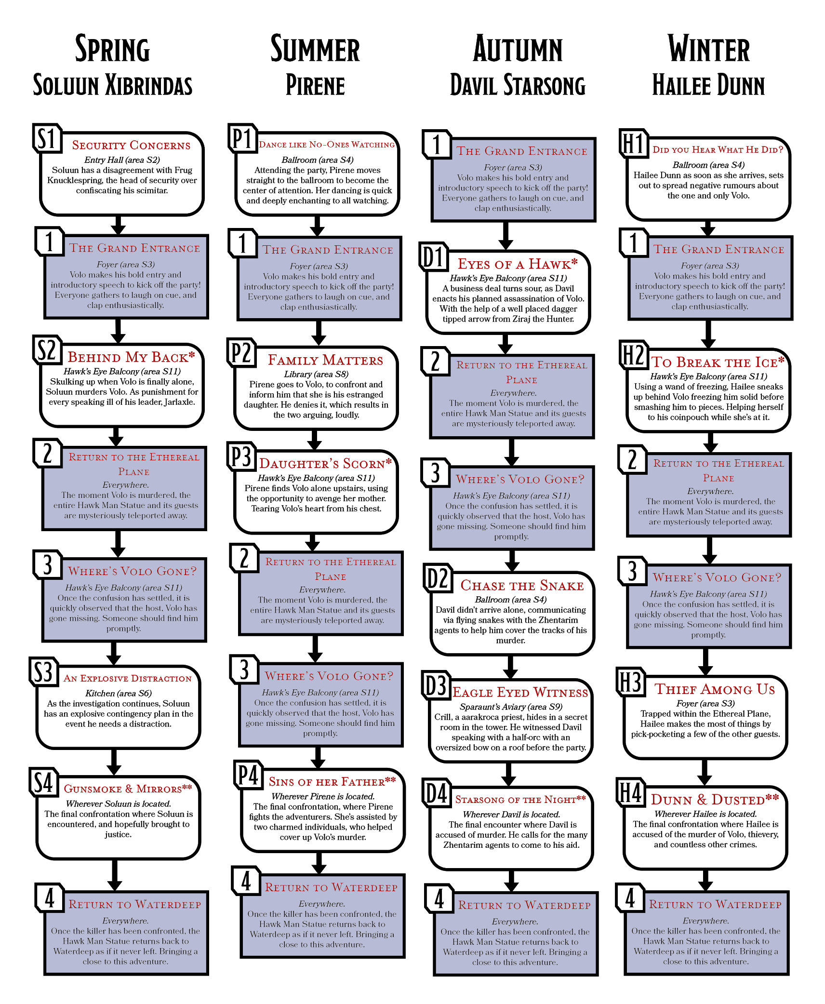

Core Encounters
The following encounters happen consistently in any runthrough of this adventure, such as setting the scene or traversing the characters to and from the Ethereal Plane.

1. The Grand Entrance
Location: Foyer (area S3)
Servants of the tower begin to clink glasses, informing and guiding all the guests back into the foyer in order for Volo to make his grand arrival. The man of the hour is fashionably late, descending down the stairs with a copy of his new book and a glass of wine in hand. Read or paraphrase the following:

Emerging from the spiral staircase, with a vibrant blue leather tome in one hand and a glass within the other, is the one and only Volothamp Geddarm.
“Evening! Ho, ho, one and all. Welcome to this exquisite evening to celebrate the release of my newest book, Volo’s Enchiridion to Making Friends.”
Volo pauses, bringing the book into both hands and raising it above his head dramatically.
“A book that promises to aid each and everyone one of you in navigating the battlefield that is making friends. I have travelled the land far and wide, and there is nothing more essential than a few allies to back you up. Which is why I’ve gathered you all here, with hopes that by the end of the night, we’re all friends!”

The four culprits are all in attendance, scattered throughout the foyer. Depending on the season, Volo can make a different closing statement to foreshadow the events to come:
Spring. “Word travels quickly in Waterdeep, let us hope the popularity of my newest book spreads far and wide!”
Volo’s talk ends to a cautious applause, except for a few individuals such as Soluun Xibrindas, who skulks in the shadows scowling.
Summer. “Because, while we cannot pick our family, we can certainly pick our friends.”
Throughout Volo’s entire speech, Pirene is making a concentrated effort to divert as much attention away from him. Laughing loudly with a group of guests formed around her.
Autumn. “We’re fortunate to be inside the Hawk Man statue, where the sights from the balcony are to die for! Let the party commence!”
At this point, Davil Starsong is yet to arrive. But fifteen minutes after the talk ends, he appears in a hurry. Searching the foyer for wherever Volo could’ve gone.
Winter. “Now, I’ve spoken enough. I say we kick the celebrations off post haste. Let’s break the ice as they say!”
Hailee Dunn uses everyone's focus on Volo as another opportunity to pickpocket, however as his talk proceeds she grows increasingly angry, to the point of stopping with clenched fists and openly glaring at Volo.

2. Return to the Ethereal Plane
Location: Everywhere.
The very moment life leaves Volo’s body, a great cosmic disturbance causes the Hawk Man Statue and all those inside it to return to the Ethereal Plane. Read or summarise the following to the characters:

An echoing rush of crackling magic suddenly rushes itself over you all. In a brief instance you feel the ground beneath you, the entire statue begins to fall, and a moment after you fall with it. The weightlessness is over in a fraction of a second, but the chaos of guests, ornaments, and glasses now scattered across the floor certainly remains.

The process of travelling across the planes is not a comfortable one, requiring each character to make a DC 8 Dexterity saving throw or be knocked prone in the sudden shift. For added fun, any character that has never done planar travel makes a DC 8 Constitution saving throw or feel significantly queasy for 1 minute. There are three views out of the statue, at the entrance (area S1), at the balcony (area S11) and the Sparaunt Aviary (area S9).
Any character looking out easily identifies that the statue is no longer in Waterdeep, while a successful DC 16 Intelligence (Arcana) check deduces the surroundings to be of the Ethereal Plane. A thin veil seems to encapsulate the entire statue, preventing everything within from turning noncorporeal.

3. Where’s Volo Gone?
Location: Anywhere.
Once the commotion of transporting planes has settled, every guest is understandably in a state of panic, unknowing of what exactly transpired. The guards of Sparaunt tower do their best to maintain control or decorum. However, it doesn’t take long for many of the guests to rather loudly observe that Volo hasn’t been seen in a long while.
Some guests may even begin to blame Volo for the sudden disturbances, but the adventuring party are quickly informed by guards that Volo was last spotted heading up to the Hawk’s Eye Balcony (area S11).

4. Return To Waterdeep
Location: Everywhere.
Whenever the killer of Volo is brought to justice or remains undiscovered, the magic that caused the statue to vanish works once more. There is a tremendous crash, as the entire building staggers during the planar travel. The tilt of the Hawk Man statue is now a little more extreme, causing all the floors inside to be at a perceivable slant.
Vajra Safahr. Emerging into the tower, joined by four members of the Watchful Order of Magists and Protectors, Vajra scans her surroundings. Being the Blackstaff of Waterdeep, all the walking statues fall under her jurisdiction. She quickly assesses the situation, learning of the characters’ involvement while evacuating the entire tower due to safety concerns.
As the characters emerge outside, it is well into the late evening, and much of Waterdeep seems as peaceful as it was left. griffon riders expedite the process of getting people down from the entrance. At the bottom, a few investigators ask for accounts of what happened, but ultimately Vajra interjects to allow the adventurers to leave.

Optional Encounters
The following encounters all involve two of the culprits encountering one another to provide red herrings, raise suspicion, or involve the other culprits with the main story arc. Each encounter is designed to happen within the evenings timeline as shown within the encounter chain diagram. It is also possible for these encounters to all happen off screen, and to be simply revealed through interrogating the culprits involved.

O1. Ballroom Blitz
Location: Ballroom (area S4) involving Pirene, the Half-Nymph x Hailee Dunn
Following Pirene’s entrancing dance that captured the attention of the entire ballroom (described in encounter P1 Dance Like No-Ones Watching), she spies Volo and moves hastily towards him. Pirene inadvertently bumps into Hailee Dunn, who takes offence, and the two engage in a heated argument. The yelling escalates to the point where two guards are required to step in and separate them both.
Summer. During Summer, the guests asked about the argument hint that it was Pirene’s actions that escalated the conflict, whereas others would aggressively refuse that Pirene could ever be at fault, a successful DC 18 Wisdom (Insight) seems that the guests were enraptured by Pirene’s performance.
Winter. In Winter, the surrounding guests not only identify Hailee as the main aggressor but the one who was spreading negative rumours about Volo. Hailee also used the confusion to pickpocket a few of the guests, which is spotted by any character who succeeds at a DC 20 Wisdom (Perception) as she storms off, bumping into another guest.

O2. Stealing Whats Mine
Location: Entry Hall (area S2) involving Soluun Xibrindas x Davil Starsong
Following Volo’s opening speech, Soluun sneaks into the entry hall to steal back his scimitar which was confiscated by Frug Knucklespring. The guards have temporarily moved into the foyer, while Volo’s grand entrance is being made. Davil, as he arrives at the party late, witnesses Soluun collecting the scimitar. If the characters are there to witness the theft, Soluun would excuse his own behaviour by suggesting the weapon holds sentimental value, and potentially offer a gold bribe if the characters would be receptive to it.
Spring. Soluun proceeds to use the scimitar as a murder weapon, before concealing it within his leather tunic. Davil happily tells the adventuring party that he witnessed Soluun taking the scimitar, believing it to be a good opportunity to stay in the adventurers’ favor.
Autumn. When the adventurers come to interrogate Davil, he informs them that he saw a drow stealing a blade. Davil hopes that this is enough information to distract the party, and stop them from asking him additional questions.

O3. Mind If I Intrude?
Location: The Library (area S8) involving Pirene, the Half-Nymph x Davil Starsong
Pirene and Volo engage in a heated argument, where she reveals that she is enfact his estranged daughter. A fact that Volo initially vehemently disagrees. After arriving late, Davil intrudes the argument to offer Volo an escape, or more importantly get him alone to discuss a business opportunity.
Summer. Pirene is furious at both Volo and Davil and storms out, rather than let the pair leave her alone. She will later use this encounter to say Davil was the last person to see Volo alive, deflecting any accusations.
Autumn. Before Volo is killed, Pirene reports that Davil was the last person to see him alive. While she may confess that they were arguing, Pirene reveals to the party that she is Volo’s estranged daughter, but shares no love for the now deceased scholar. Davil will use the encounter as probable cause to suggest Pirene to be the killer.

On Volo’s Death
The moment that Volo is killed, the Return to the Ethereal Plane event is triggered. This returns the Hawk Man statue back into the Ethereal Plane until the murder is solved, or at least until Vajra Safahr, the current Blackstaff, can be informed of its disapperance and determine the best course of action.

Aftermath
Once the culprit has been confronted, the sudden return back to Waterdeep is met with a force of City Watch and griffon cavalry at the ready on the scene. At this point, the murderer can be handed over to the authorities, if they’ve been successfully apprehended. Otherwise, a series of questions from Vajra Safhr the Blackstaff and the many Watchful Order of Magists and Protectors will quickly identify the characters as being the heroes of the day. The matter of Volo’s body, and what exactly caused Sparaunt Tower to vanish remains unanswered, but finding those answers can lead to adventures in themself!

Resurrecting Volo
Volo is a man of many connections and a respectable amount of wealth. It is very likely for him to have a will prepared, or contingency plans in the event of his death, as there are plenty of unexplored domains, or creatures to study, it would be hard to believe that Volo would be content to rest. It is possible that Elminster, an ally of Volo, sees to handling matters taking him to the Golden Spires of Waterdeep to be resurrected and tended to over a tenday.
Alternatively, resurrections are costly rituals, and it could be up to the adventuring party to fetch a diamond of value, trading within Waterdeep or going further afield in hunt of treasure. However it is done, Volo is one of the Forgotten Realm’s most iconic characters, so for some it might be a shame to have this be the end of the scholar's tale.

Resolving the Character Hooks
Word of the heroes' success will spread rather quickly around Waterdeep, afterall what noble doesn’t enjoy the occasional bit of gossip.

A Secret Invitation
The sender of the mysterious letter can present themselves as the heroes return, who could be any of the following:
- Elminster. Concerned for his friend’s wellbeing, Elminster cleverly recruited the help of an adventuring group to get involved and settle matters.
- Jarlaxle. A man who pulls many strings, it is beneficial for Jarlaxle to be enthralled in Waterdeep’s politics despite his nonchalant objections. Plus if Davil Starsong is the villain, seeing the Zhentarium’s control ruptured can only benefit the drow.
- Volo himself. Volo is no fool, and when plots to kill him are set into motion, his innate danger sense would tingle. The very same courier appears to deliver Volo’s explanation for hiring the party, and see them rewarded.
- Anyone. This list of suggestions is not exhaustive, meaning you can insert just about anyone who can further your campaign!

Faerûn’s Up and Coming Heroes
In the days following Volo’s party, all of Waterdeep begins to endlessly speculate about the new band of heroes who happened to save the day. People of all backgrounds go out of their way to find the party, asking for assistance with tasks from mundane to mysterious and occult. Others might suggest the heroes begin a mercenary business within the city, offering financial support in exchange for royalties.

Volo’s “Best” Friends
A somewhat sombre end to the adventure, as the party comes to terms with the death of their friend. There is the opportunity for them to be directly involved in Volo’s eventual resurrection, or depending on what suits your campaign for a memorial service to be held. Some of the most iconic characters will travel far and wide to attend Volo’s funeral.

Further Adventures
This brings us to the end of the adventure, but that doesn’t mean everything has to cease. There are a plethora of options to expand the scope of this adventure, and enhance a Waterdeep: Dragon Heist campaign. Your answers to the following questions forms the basis for further adventures:
- How does Jarlaxle respond to one of his lieutenants being caught for murdering Volo?
- Does the City Watch believe there to be more going on than the characters’ descriptions of events?
- Does Perine’s mother ever discover what her daughter enacted?
- How does Vajra Safhr discover the cause of the Hawk Man statue’s disappearance?
- If Davil Starsong has been apprehended, how does the remaining Doom Raiders react?
- What is the truth behind Lady Sparaunt’s mysterious behaviour and possessions?
- Does the North’s review of Ten Towns get changed, or worsen because of Hailee Dunn’s actions?

These are just some suggestions and may vary considerably based on the events that unfold with your party. Whatever happens, the friends made and enemies throughout this adventure have repercussions that can affect the heroes’ lives for years to come.

Appendix A: Magical Items
This appendix contains information on the unique magical items not found in the Dungeon Master's Guide or Waterdeep: Dragon Heist. The items are all in alphabetical order.

Potion of Flesh Shape
Potion, uncommon
When you pour this pinkish liquid over flesh no more than 5 feet in any dimension, for 1 minute you may shape the flesh into any shape that suits your purpose. After the time expires, the flesh retains whatever shape it was formed into. The flesh can return to its original shape through the lesser restoration spell or other magic.

Wand of Freezing
Wand, rare
This wand has 7 charges for the following properties. It regains 1d6 + 1 expended charges daily at dawn. If you expend the wand’s last charge, roll a d20. On a 1, the wand crumbles to ashes and is destroyed.
Spells. While holding the want, you can use an action to expend some of its charges to cast one of the following spells (save DC 17): freezing sphere (3 charges). Alternatively, you can spend 4 charges to create a 15-foot cone of a freezing blast. Each creature in the cone must make a Constitution saving throw. A creature that fails becomes incapacitated as they are frozen solid for 1 minute. Any damage immediately ends the effect, unless it reduces the creature to 0 hit points, at which point they shatter.

Appendix B: Creatures & NPCs
Davil Starsong
Medium humanoid (elf), neutral
Armor Class 15 (chain shirt)
Hit Points 82 (15d8 + 15)
Speed 30 ft.
STR DEX CON INT WIS CHA
10 (+0) 14 (+2) 12 (+1) 16 (+3) 12 (+1) 17 (+3)
Saving Throws Dex +5, Cha +6
Skills Arcana +6, Deception +6, History +6, Insight +4, Perception +4, Performance +6
Senses darkvision 60 ft., passive Perception 14
Languages Common, Draconic, Dwarvish, Elvish
Challenge 6 (2,300 XP)
Fey Ancestry. Davil has advantage on saving throws against being charmed, and magic can’t put him to sleep.
Spellcasting. Davil is a 12th-level spellcaster. His spellcasting ability is Charisma (spell save DC 14, +6 to hit with spell attacks). He has the following bard spells prepared:
Cantrips (at will): mage hand, mending, minor illusion, vicious mockery
1st level (4 slots): cure wounds, disguise self, sleep
2nd level (3 slots): crown of madness, invisibility, suggestion
3rd level (3 slots): nondetection, sending, tongues
4th level (3 slots): compulsion, freedom of movement, polymorph
5th level (2 slots): dominate person, greater restoration
6th level (1 slot): Otto’s irresistible dance
Actions
Dagger. Melee Weapon Attack: +5 to hit, reach 5 ft. or range 20/60 ft.,, one target. Hit: 4 (1d4 + 2) piercing damage.

Hailee Dunn
Medium humanoid, chaotic neutral
Armor Class 16 (studded leather)
Hit Points 91 (14d8 + 28)
Speed 30 ft.
STR DEX CON INT WIS CHA
14 (+2) 18 (+4) 14 (+2) 11 (+0) 11 (0Y) 15 (+3)
Saving Throws Dex +7, Cha +6
Skills Athletics +4, Deception +6, Perception +3, Sleight of Hand +7, Stealth +7
Senses passive Perception 13
Languages Common
Challenge 5 (1,800 XP)
Ball Bearings (3/day). As a bonus action, Hailee can release ball beads from a pouch to cover a level 10 ft square area. A creature moving across the covered area must succeed on a DC 10 Dexterity saving throw or fall prone. A creature moving through the area at half speed doesn't need to make the save.
Cunning Action. On each of her turns, Hailee can use a bonus action to take the Dash, Disengage, or Hide action.
Evasion. If Hailee is subjected to an effect that allows her to make a Dexterity saving throw to take only half damage, she instead takes no damage if she succeeds on the saving throw, and only half damage if she fails. She can’t use this trait if she’s incapicated.
Northern Indomitability. (1/day). Hailee can reroll a saving throw that she fails. She must use the new roll.
Sneak Attack (1/Turn). Hailee deals an extra 14 (4d6) damage when she hits a target with a weapon attack and has advantage on the attack roll, or when the target is within 5 feet of an ally of Hailee that isn’t incapaciated and Hailee doesn’t have disadvantage on the attack roll.
Actions
Multiattack. Hailee makes three attacks with her ice pick.
Ice Pick. Melee Weapon Attack: +7 to hit, reach 5 ft., one target. Hit: 9 (1d8 + 4) piercing damage.
Reactions
Parry. Hailee adds 2 to her AC against one melee attack that would hit her. To do so, she must see the attacker and be wielding a melee weapon.

Pirene, the Half-Nymph
Medium humanoid (fey), chaotic neutral
Armor Class 17
Hit Points 82 (15d8 + 15)
Speed 30 ft.
STR DEX CON INT WIS CHA
10 (+0) 17 (+3) 12 (+1) 16 (+3) 17 (+3) 19 (+4)
Saving Throws Cha +6, Dex +5
Skills Acrobatics +5, Animal Handling +5, Deception +6, Insight +5, Nature +5, Perception +5, Persuasion +6
Condition Immunities charmed
Senses passive Perception 15
Languages Common, Sylvan
Challenge 5 (1,800 XP)
Innate Spellcasting. Pirene’s spellcasting ability is Charisma (spell save DC 14, +6 to hit with spell attacks). She can innately cast the following spells, requiring no material components:
At will: detect magic, druidcraft, shillelagh
1/day each: dimension door
Spellcasting. Pirene is a 7th-level spellcaster. Her spellcasting ability is Charisma (spell save DC 14, +6 to hit with spell attacks). She has the following bard spells prepared:
Cantrips (at will): guidance, produce flame, resistance
1st level (4 slots): faerie fire, fog cloud, healing word, purify food and drink
2nd level (3 slots): barkskin, hold person, spike growth
3rd level (3 slots): call lightning, dispel magic, plant growth
4th level (1 slot): polymorph
Unearthly Grace. While Pirene is wearing no armor and not wielding a shield, her AC includes her Charisma modifier. Additionally, when forced to make any saving throw, she can make a Charisma saving throw instead.
Actions
Dagger. Melee Weapon Attack: +5 to hit, reach 5 ft., one target. Hit: 6 (1d4 + 3) piercing damage.
Charm. One humanoid Pirene can see within 30 feet of her must succeed on a DC 15 Wisdom saving throw or be magically charmed for 1 day. The charmed target obeys Pirene’s verbal commands. If the target suffers any harm or receives a command that would harm themselves, it can repeat the saving throw, ending the effect on a success. If the target successfully saves against the effect, or the effect on it ends, the target is immune to Pirene’s Charm for the next 24 hours.
Stunning Glance (Recharge 5-6). Pirene attempts to stun a creature within 30 feet of her with a look. If that creature and Pirene can see each other, the creature must succeed on a DC 15 Constitution saving throw or be stunned for 1 minute. The creature can repeat the saving throw at the end of each of its turns, ending the effect on a success.

Soluun Xibrindas
Medium humanoid (elf), neutral evil
Armor Class 18 (studded leather, shield)
Hit Points 91 (14d8 + 28)
Speed 30 ft.
STR DEX CON INT WIS CHA
13 (+1) 18 (+4) 14 (+2) 11 (+0) 13 (+1) 14 (+2)
Saving Throws Dex +6, Con +4, Wis +3
Skills Deception +4, Perception +3, Stealth +8
Senses darkvision 120 ft., passive Perception 13
Languages Common, Elvish, Undercommon
Challenge 5 (1,800 XP)
Fey Ancestry. Soluun has advantage on saving throws against being charmed, and magic can’t put him to sleep.
Gunslinger. Being within 5 feet of a hostile creature or attacking at long range doesn’t impose disadvantage on Soluun’s ranged attack rolls with a pistol. In addition, he ignores half cover and three-quarters cover when making ranged attacks with a pistol.
Innate Spellcasting. Soluun’s spellcasting ability is Charisma (spell save DC 12). He can innately cast the following spells, requiring no material components:
At will: dancing lights
1/day each: darkness, faerie fire, levitate (self only)
Sunlight Sensitivity. While in sunlight, Soluun has disadvantage on attack rolls, as well as on Wisdom (Perception) checks that rely on sight.
Actions
Multiattack. Soluun makes two scimitar attacks.
Scimitar. Melee Weapon Attack: +6 to hit, reach 5 ft., one target. Hit: 7 (1d6 + 4) piercing damage. Any creature dealt damage by the scimitar must succeed on a DC 13 Constitution saving throw or be poisoned for one hour.
Poisonous Pistol. Ranged Weapon Attack: +6 to hit, reach 30/90 ft., one target. Hit: 9 (1d10 + 4) piercing damage plus 11 (2d10) poison damage..

