Les Avions de 1919 à 1944 (images)

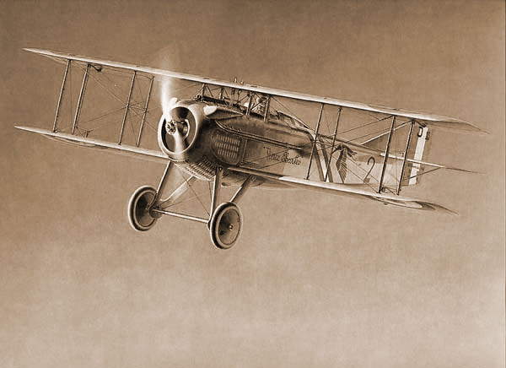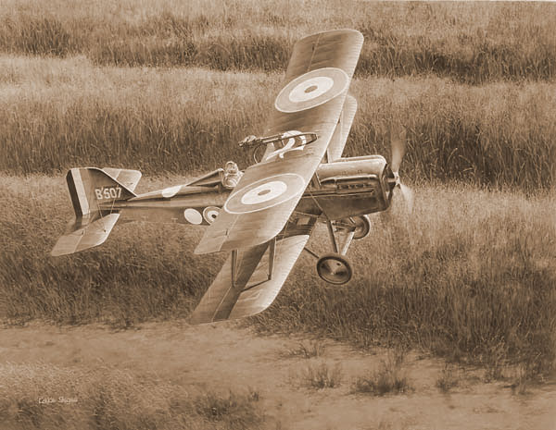
Spad s vll fighter [france] 1916 R.a.f(royal aircraft factory)se 5a fighter [u.k.] 1916

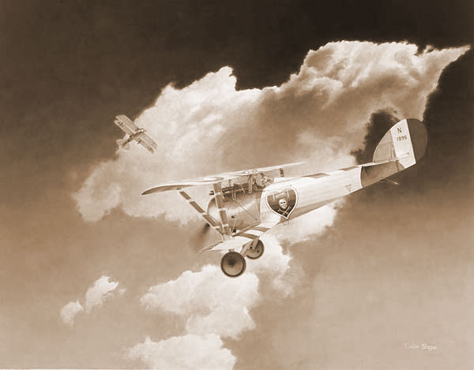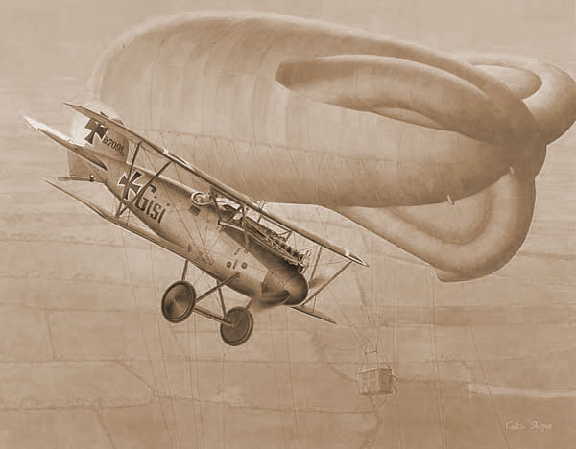
Nieuport 25c fighter [france] 1917 Albatros werke d.va fighter [allemagne] 1917

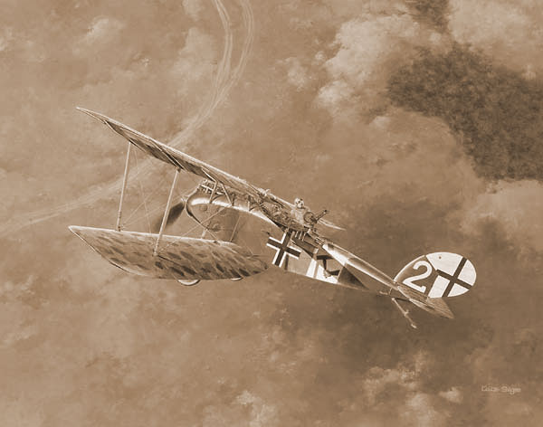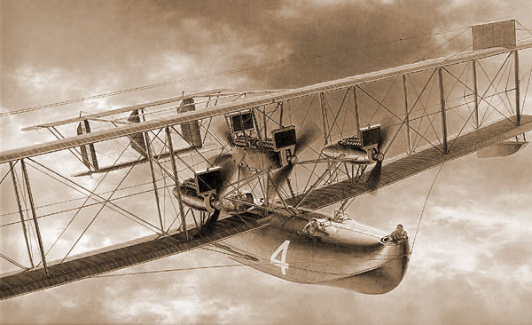
Halberstadt close-support aircraft [allemagne] Navy-curtiss nc-4 flying boat [u.s.a- 1918 navy] 1918

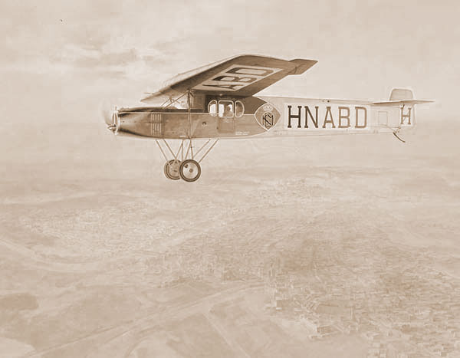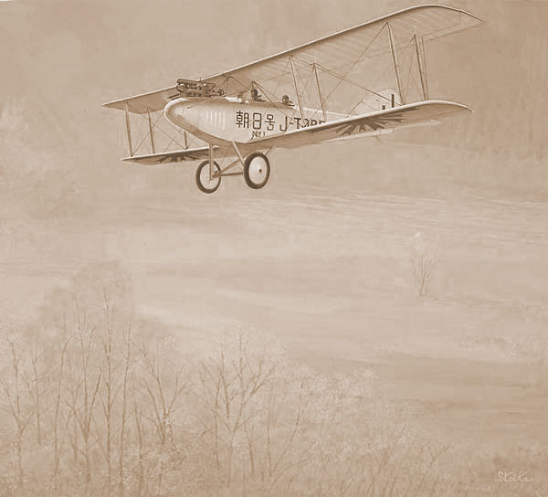
Fokker f.II passenger transport [pays-bas] 1919 Nakajima type 5 biplane/trainer [japon] 1920

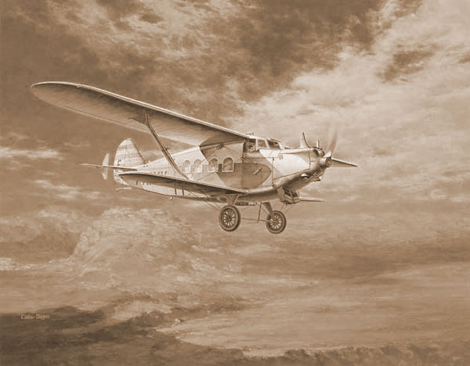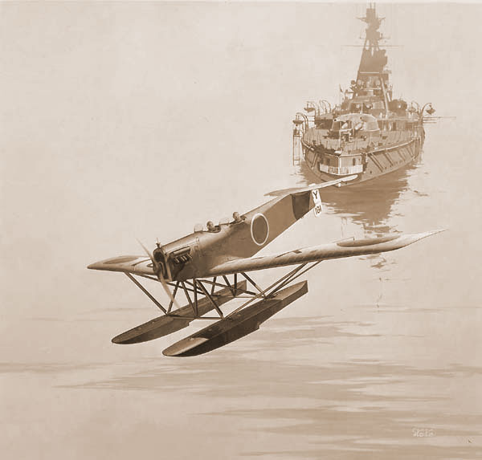
Breguet 280t passenger transport [france] 1922 Navy hanza-brandengurg reconnaissance-seaplane [japon] 1923

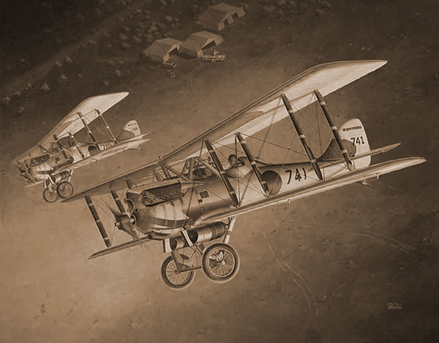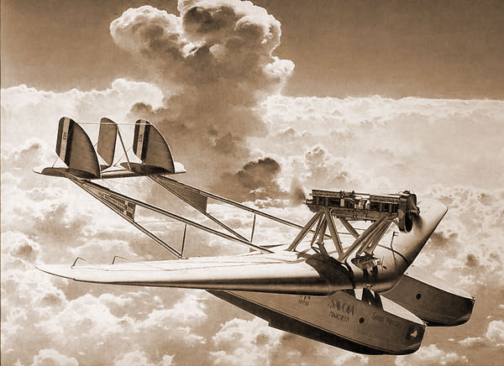
Army ko-4 fighter (nieuport 29c 1) [japon/france] Savoia marchetti s-55 Saint Maria flying 1923 boat [Italie] 1924

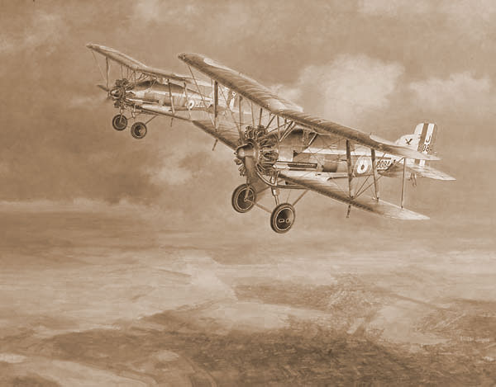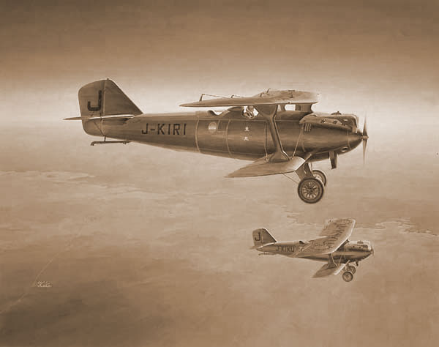
Gloster gamecock1 fighter [u.k.] 1924 Breguet 19a2kai long-range com-plane (kd) [japon] 1925

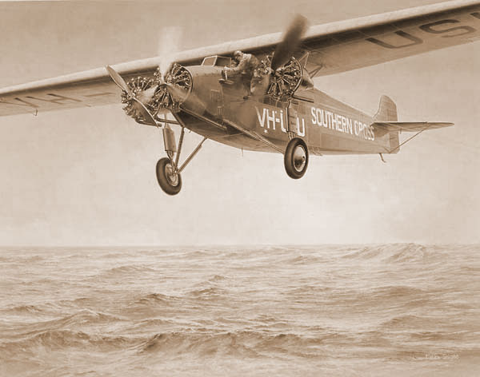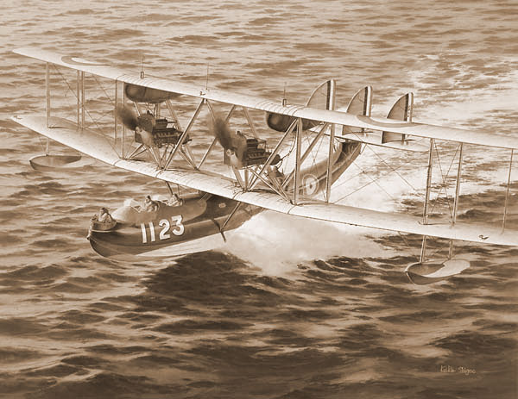
Fokker kingsford’s southern cross [pays-bas] Supermarine Southampton1 patrol flying 1925 boat [u.k.] 1925

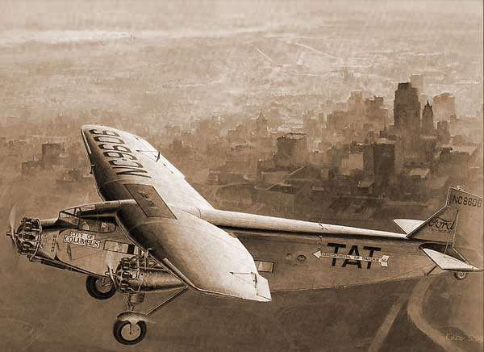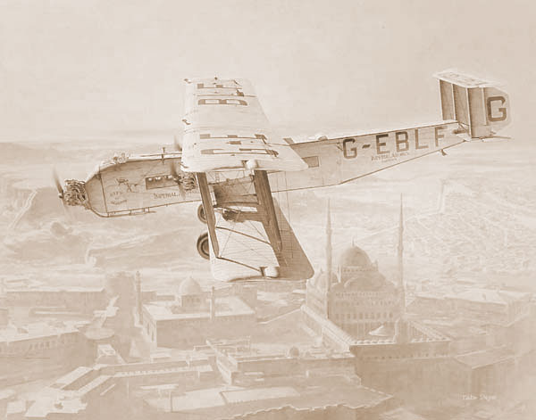
Ford 5-at trimotor passenger aircraft [u.s.a.] Armstrong whitworth argosy passenger 1926 transport [u.k.] 1926

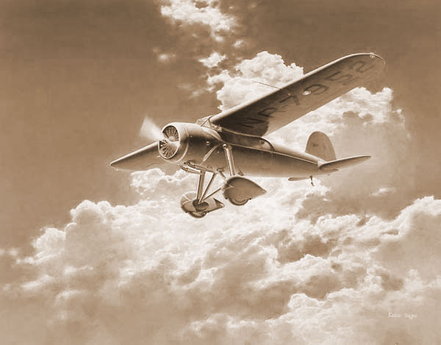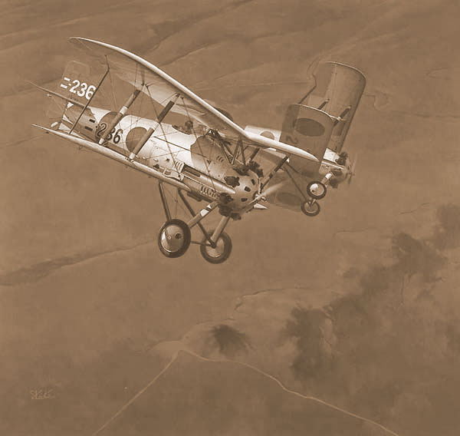
Lockheed vega5 utility airplane [u.s.a.] 1927 Navy type 3 carrier fighter [japon] 1927

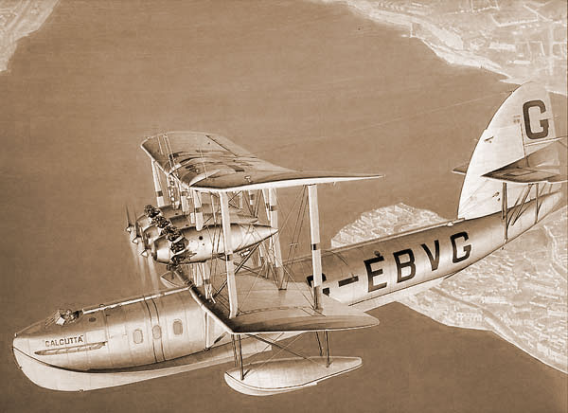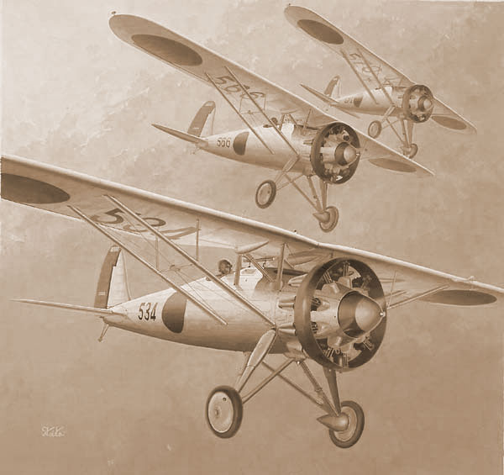
Short S.8 calcutta flying boat [u.k.] 1928 Nakajima type 91 fighter [japon army]
1928

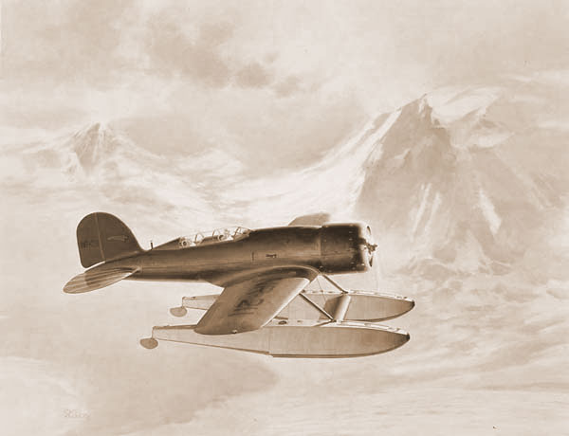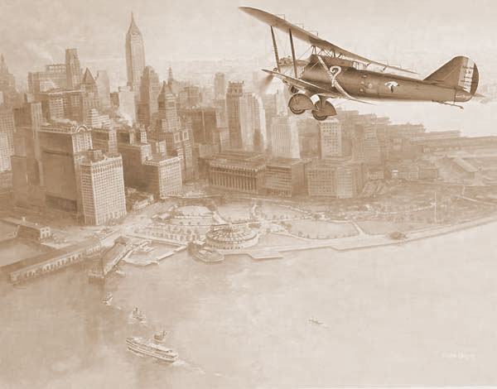
Lockheed sirius utility airplane [u.s.a.] 1929 Breguet super tr point d’interrogation [france] 1929

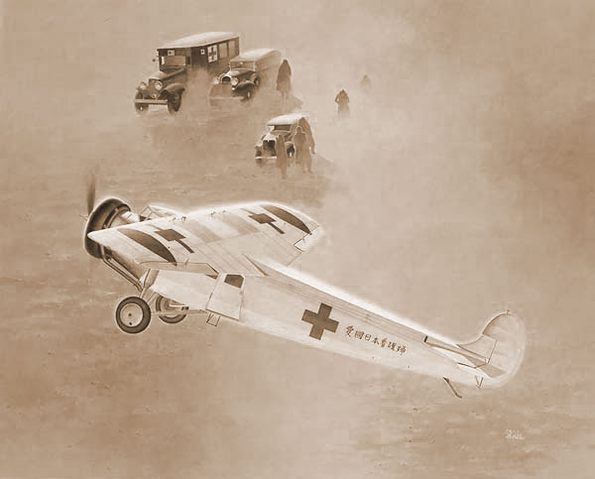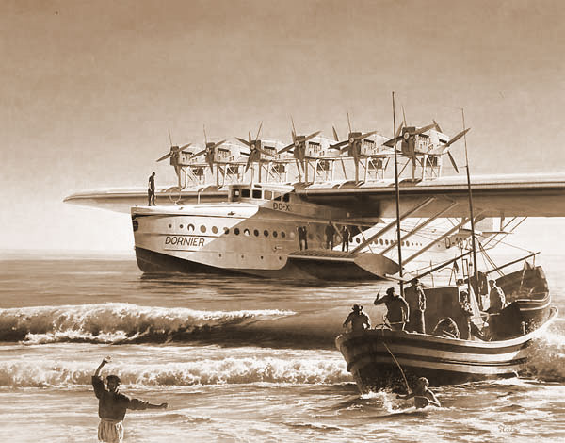
Nakajima fokker super-universal passenger-plane Dornier do x flying boat [allemagne] 1929 [japon] 1929

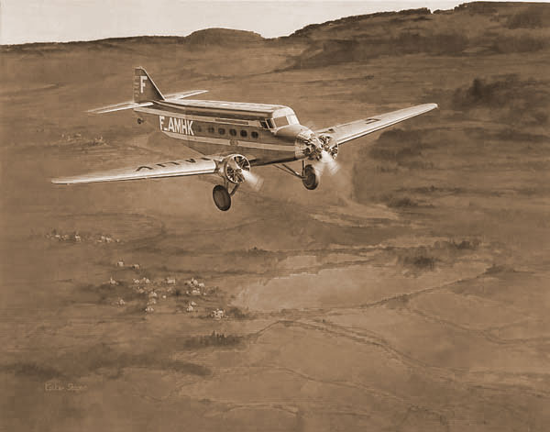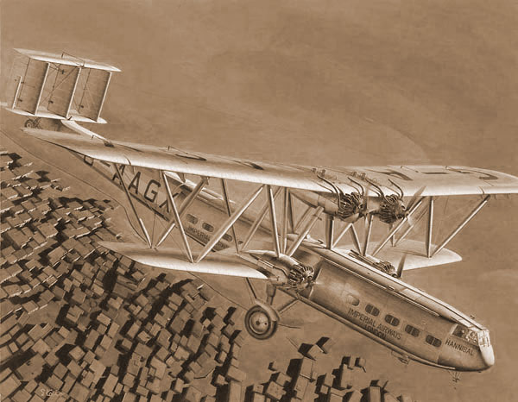
Wibault penhoet 282.t12 passenger transport Handley page hp42 passenger transport [france] 1930 [u.k.]1930

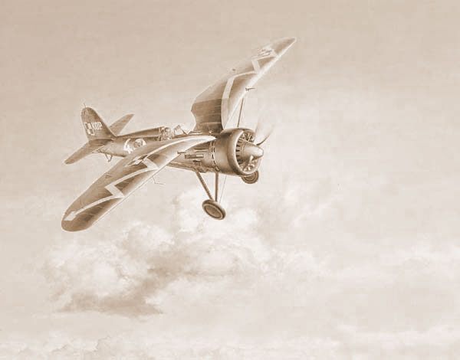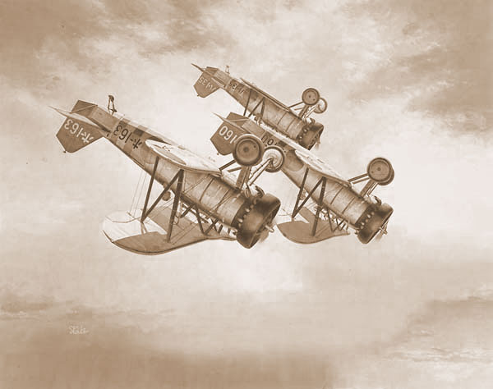
Pzl (panstwowe zaklady lotnicze) p-11c fighter Nakajima type 90 carrier fighter [japon] [pologne] 1931 1932

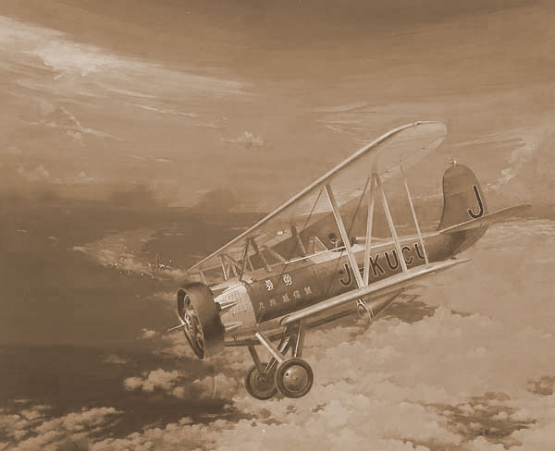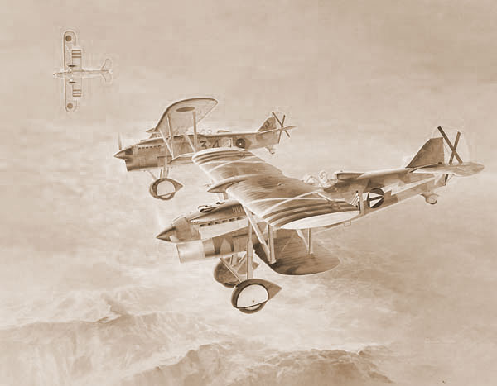
Nakajima p-1 mail-plane [japon] 1933 Fiat cr 32 fighter [italie] 1933

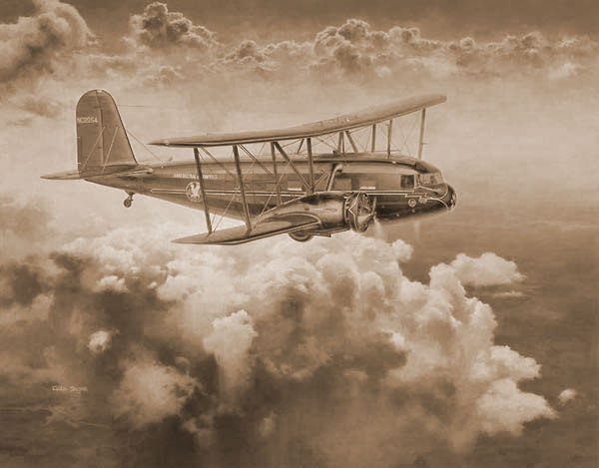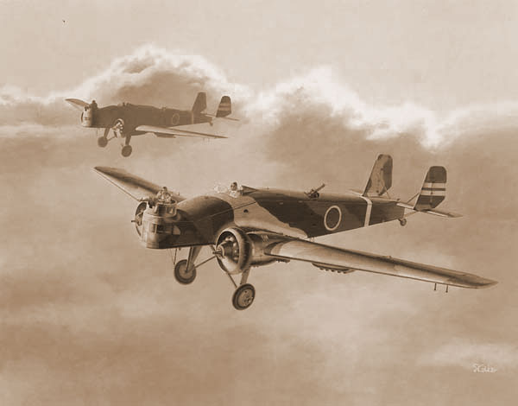
Curtiss-wright condor transport [u.s.a.] 1934 Mitsubishi type 93 light bomber mk.1 [japon] 1933

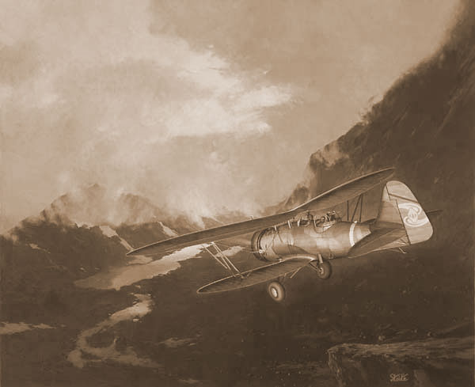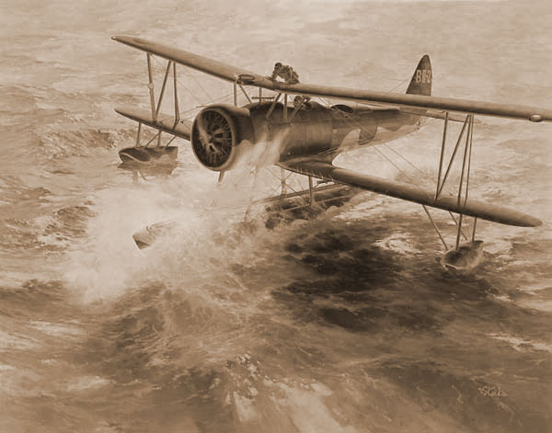
Nakajima type 94 reconnaissance-plane ki-4 Nakajima type 95 reconnaissance seaplane [japon] 1934 [japon] 1934

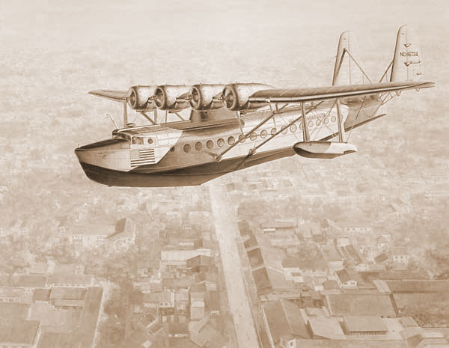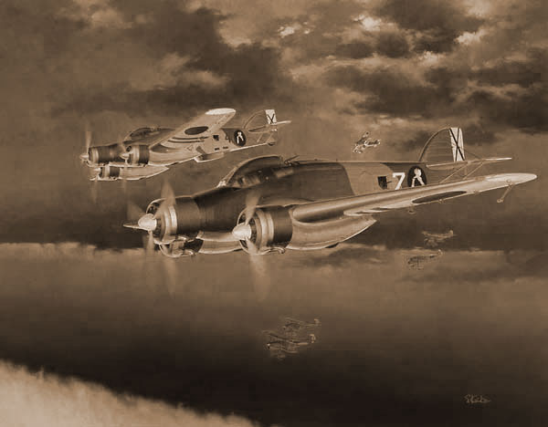
Sikorsky s42b passenger flying boat [u.s.a.] Savoia-marchetti sm79-1 sparviero bomber 1934 [italie] 1934

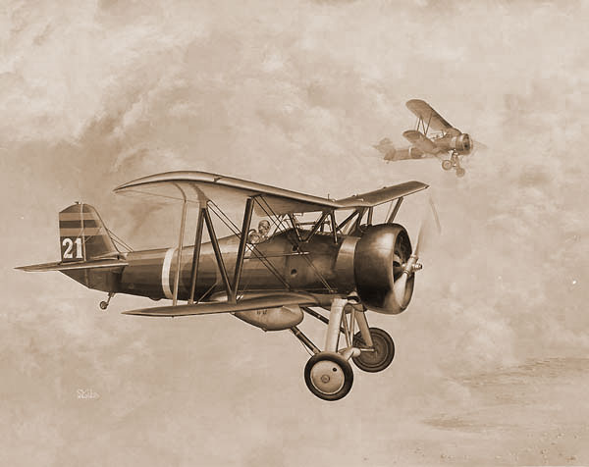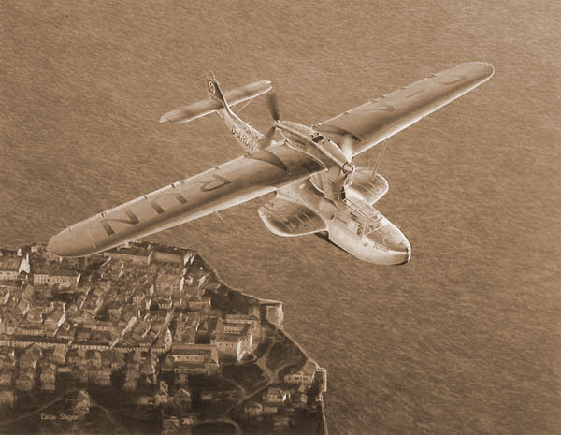
Nakajima type 95 carrier fighter [japon] 1935 Dornier do 18d-1 flying boat [allemagne] 1935

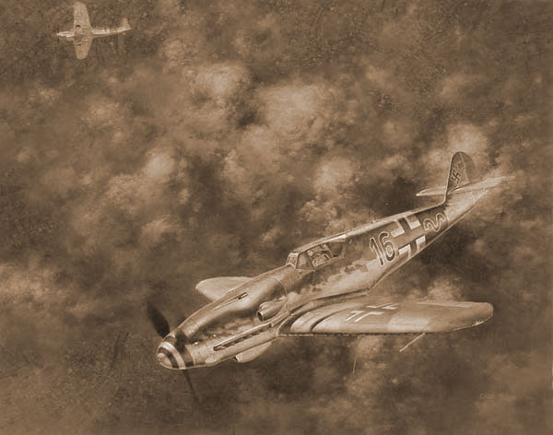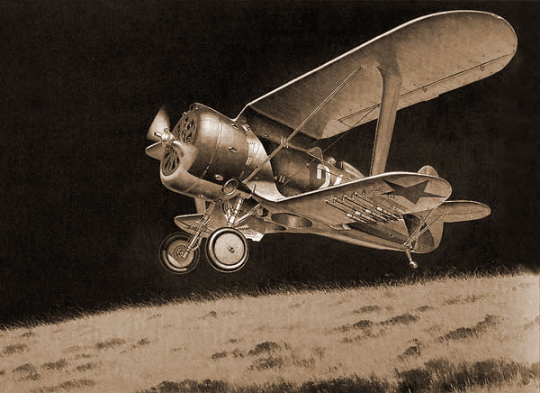
Messerschmitt bf109 k-4 fighter [allemagne] 1935 Polikarpov i-153 chaika fighter [u.r.s.s.] 1934

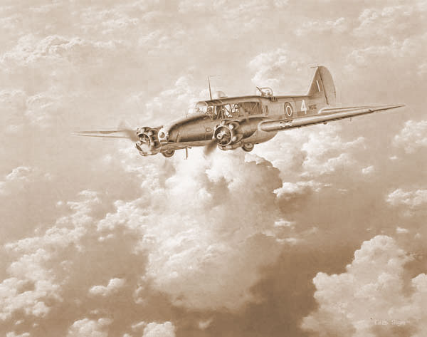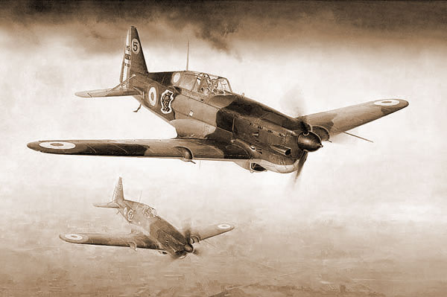
Avro anson coastal patrol trainer transport Morane-saulnier ms406c1 fighter [france] [u.k.] 1935 1935

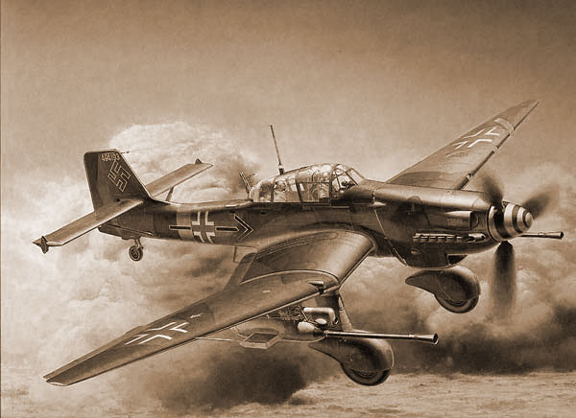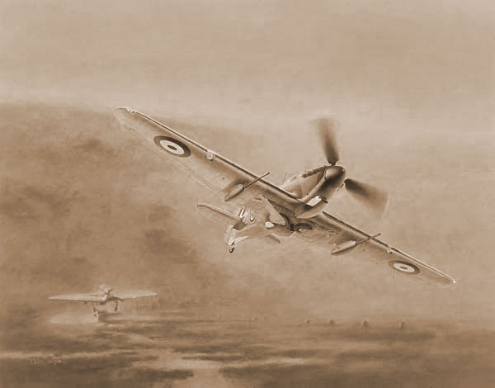
Junkers ju87 g-2 stuka dive bomber [allemagne] Hawker hurricane 2d fighter [u.k.] 1935 1935

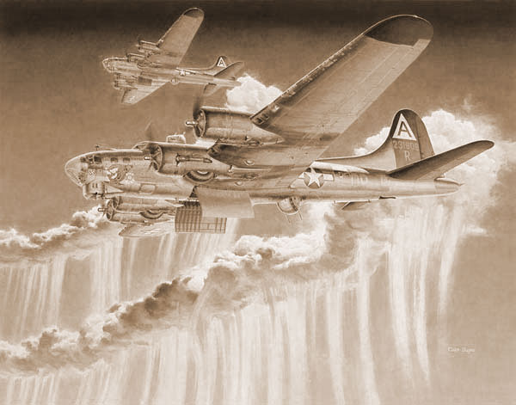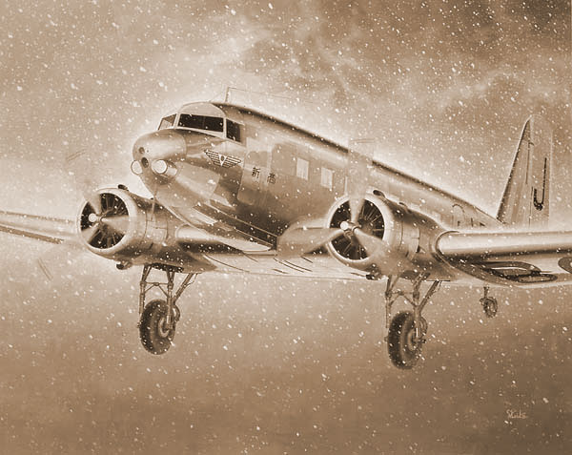
Boeing b-17g flying fortress bomber [u.s.a.] 1935 Nakajima douglas dc-2 passenger-plane(kd) [japon] 1936

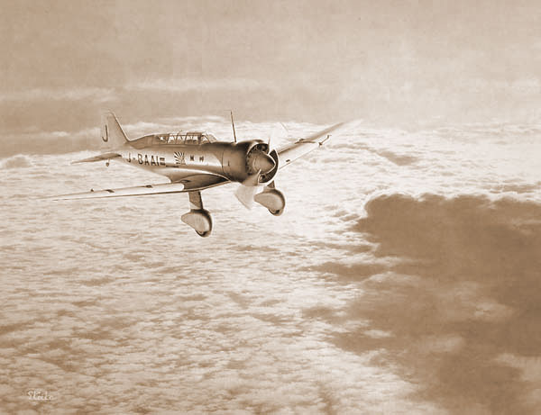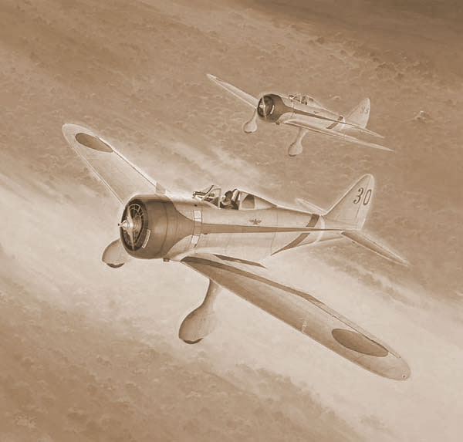
Mitsubishi karigata liaison plane kamikaze Nakajima type 97 fighter [japon] 1936
[japon] 1936

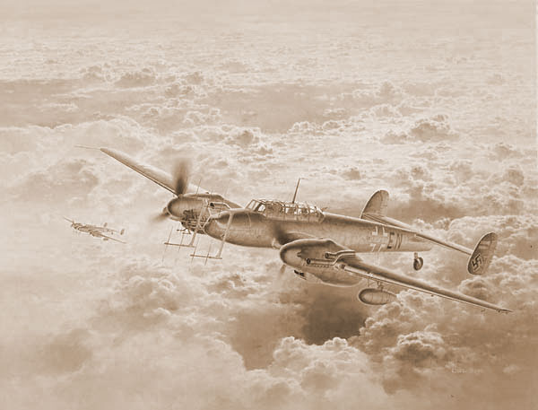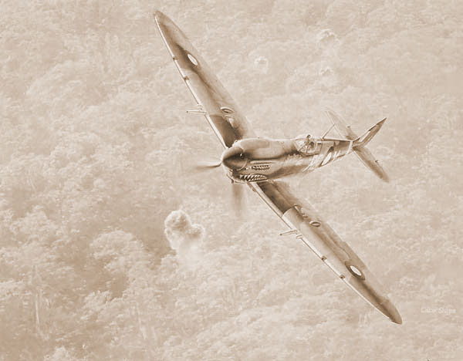
Messerschmitt bf110 fighter [allemagne] 1936 Supermarine spitfire mk vIII fighter [u.k.] 1936

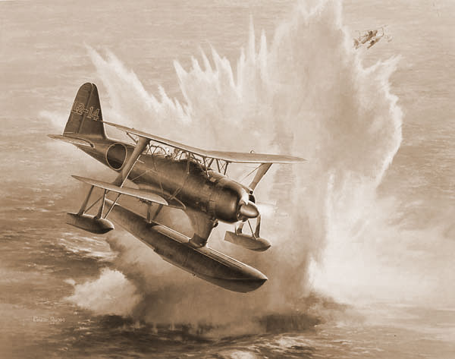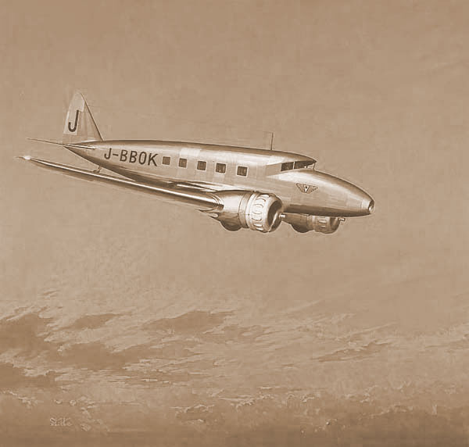
Mitsubishi type o 0bservation seaplane [japon] Nakajima at-2 passenger-plane [japon]1936
1936

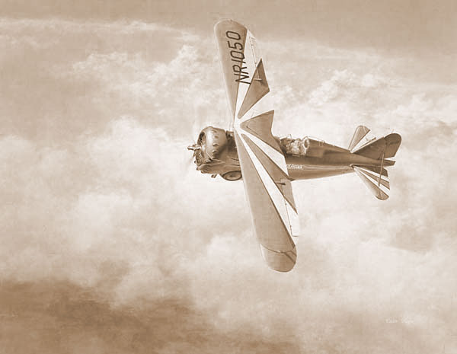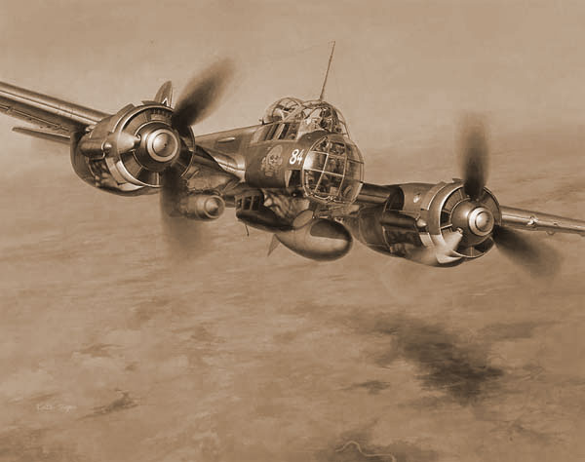
Grumman g22 gulf hawk II sport plane [u.s.a.] Junkers ju88 a-4 bomber [allemagne] 1936
1936

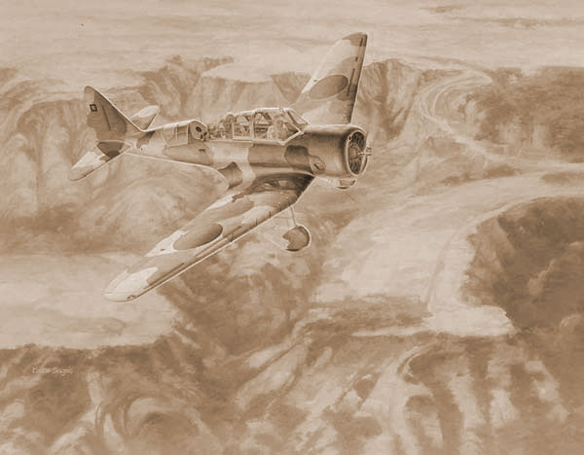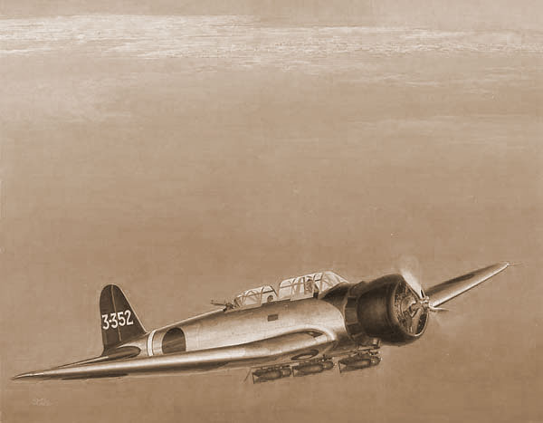
Tachikawa type 98 close-support reconnaissance Nakajima type 97 -1 carrier attack-bomber [japon]1937 [japon] 1937

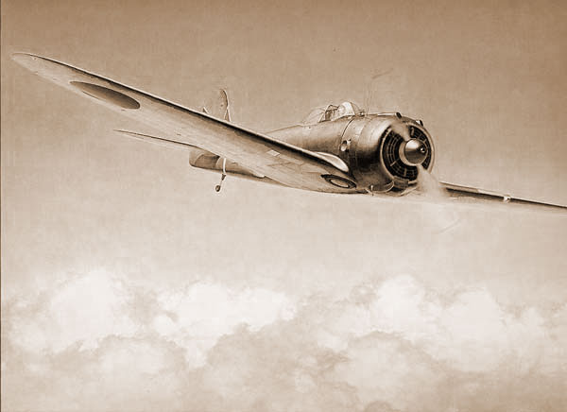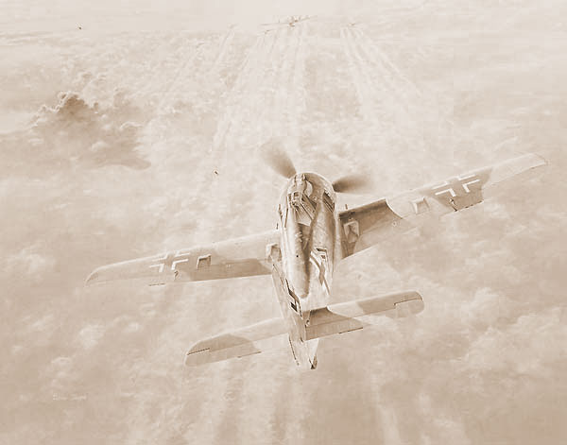
Nakajima type1 fighter hayabusa [japon] 1938 Focke-wulf fw190 a8/r8 fighter [allemagne] 1939

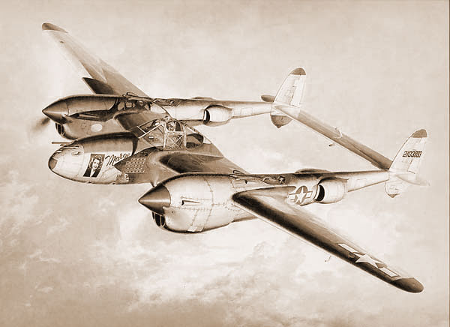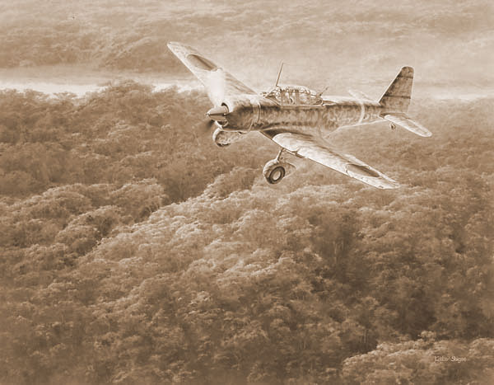
Lockheed p-38j lightning fighter [u.s.a.] 1939 Mitsubishi type99 assault/ tactical reconnaissance [japon] 1939

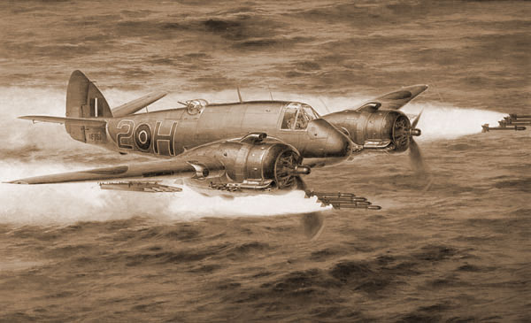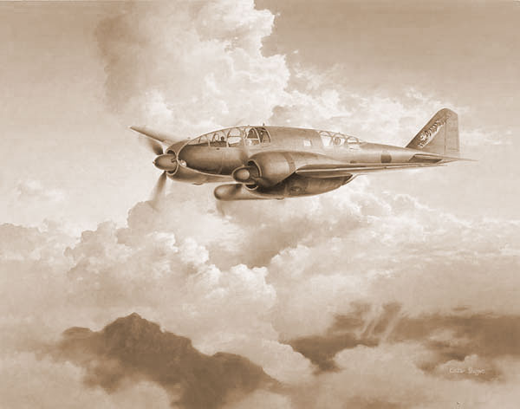
Bristol beaufighter mk10 torpedo-fighter [u.k.] Mitsubishi type100 strategic recon 1939 [japon] 1939

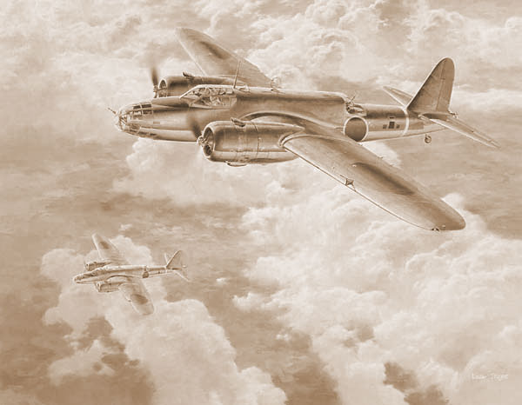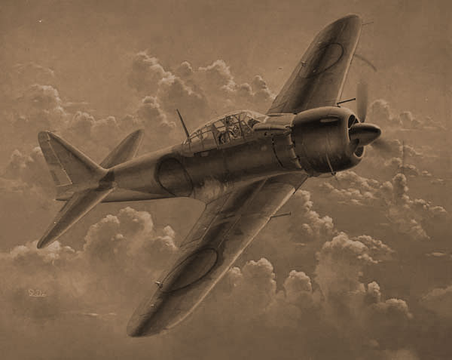
Nakajima type 100 bomber donryu [japon] 1939 Mitsubishi type o carrier fighter [japon] 1939

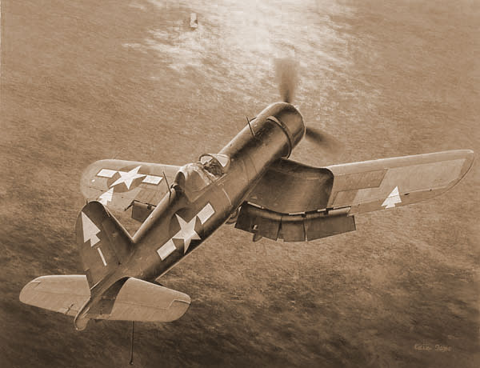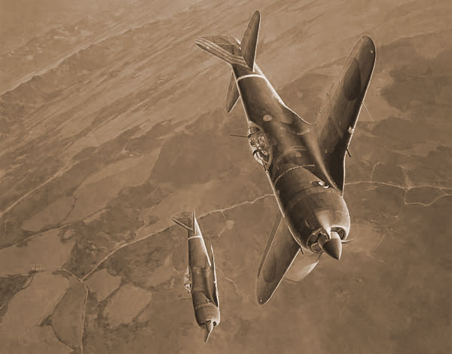
Vought f4u-1d corsair carrier fighter [u.s.a.] Nakajima type 2 fighter shouki [japon] 1940 1940

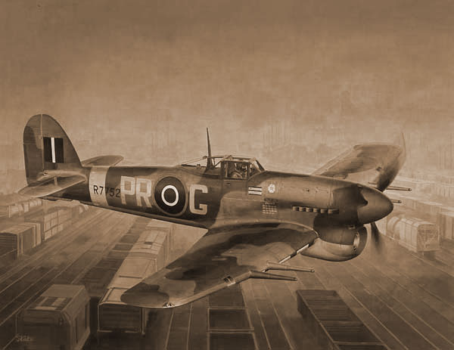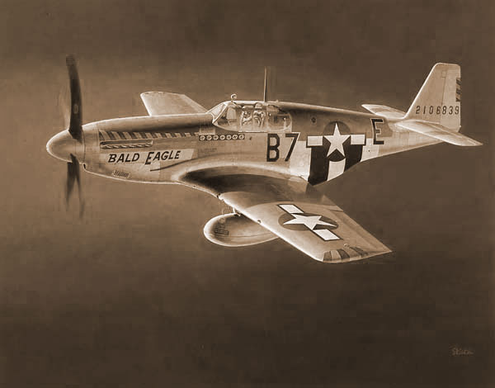
Hawker typhoon fighter [u.k.] 1940 North american p-51b mustang fighter [u.s.a.] 1940

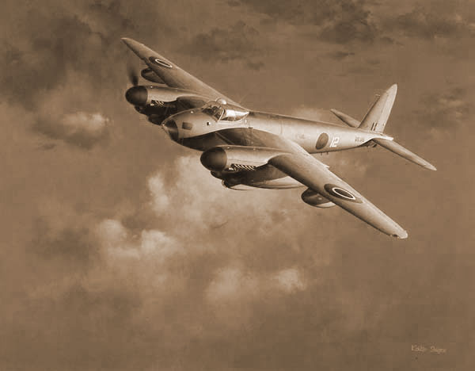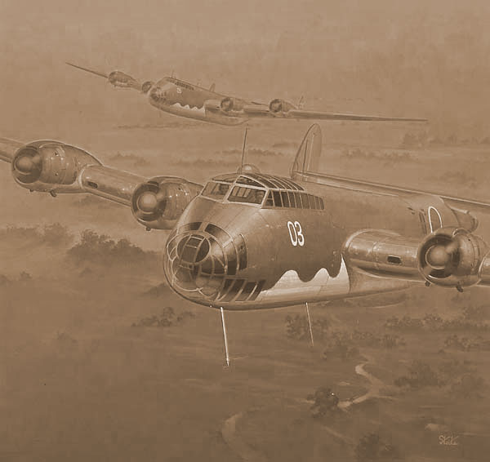
De havilland mosquito reconnaissance aircraft Nakajima experimental attack-bomber [u.k.] 1940 shinzan [japon] 1940

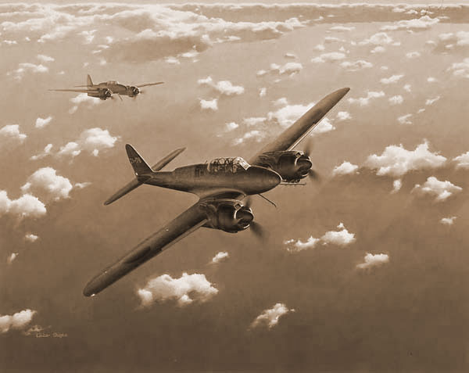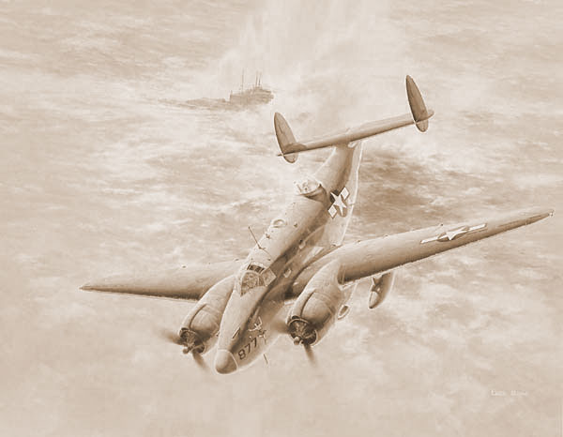
Nakajima night fighter gekkon [japon] 1941 Lockheed-vega pv-1 ventura patrol aircraft [u.s.a] 1941

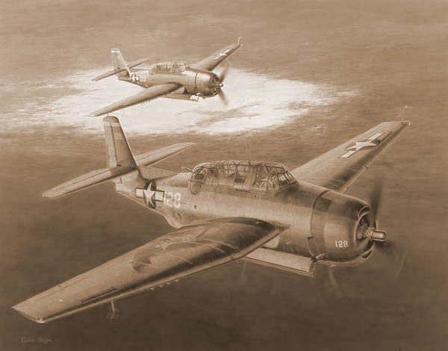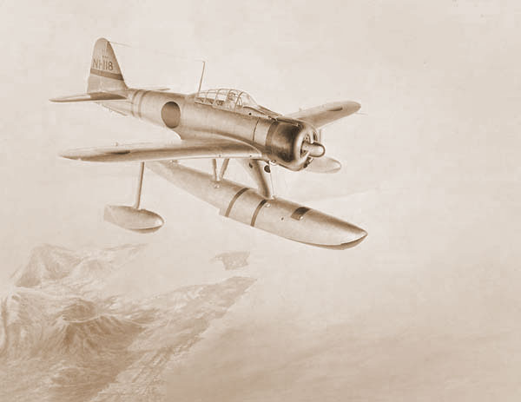
Grumman avenger carrier attacker [u.s.a.] 1941 Nakajima type 2 floatplane fighter [japon] 1941

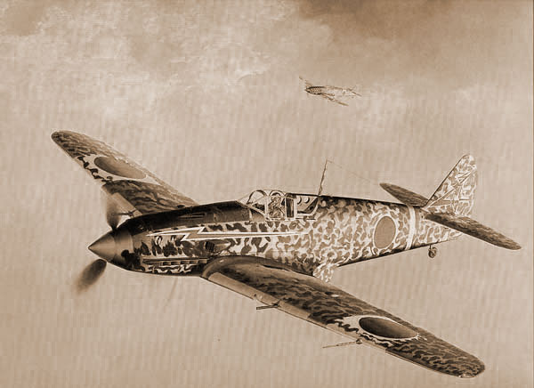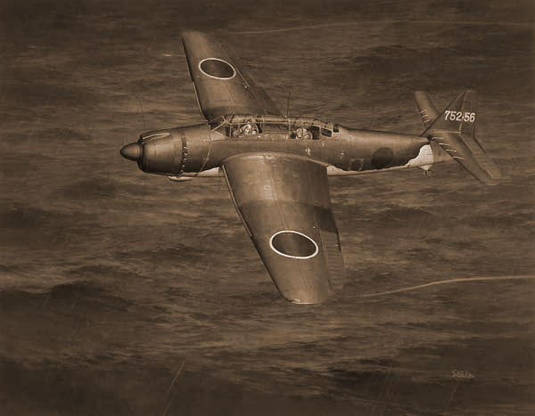
Kawasaki type 3 fighter hien [japon] 1941 Aichi caprier torpedo bomber ryuse [japon] 1941

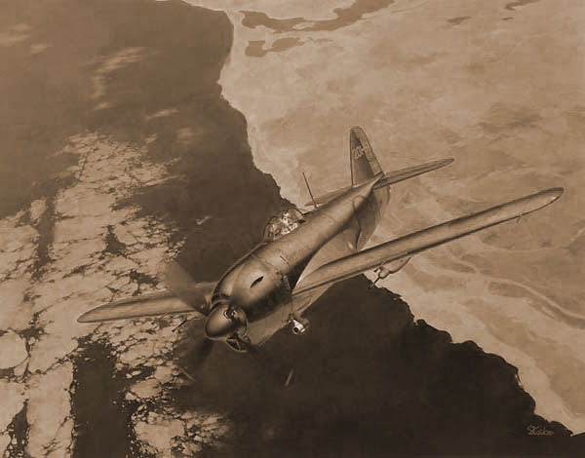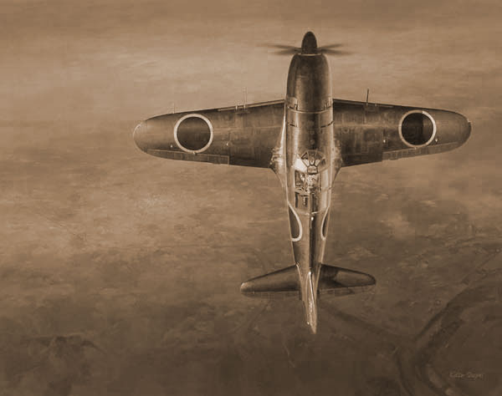
Kawanishi intercepter shiden [japon] 1942 Mitsubishi interceptor raiden [japon] 1942

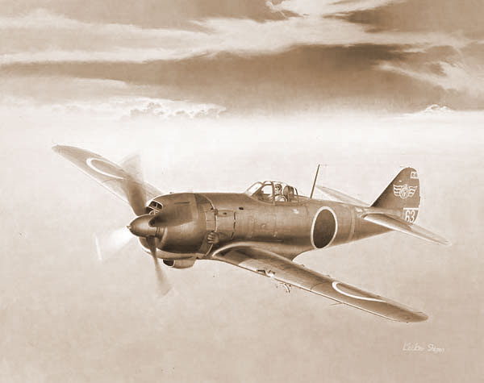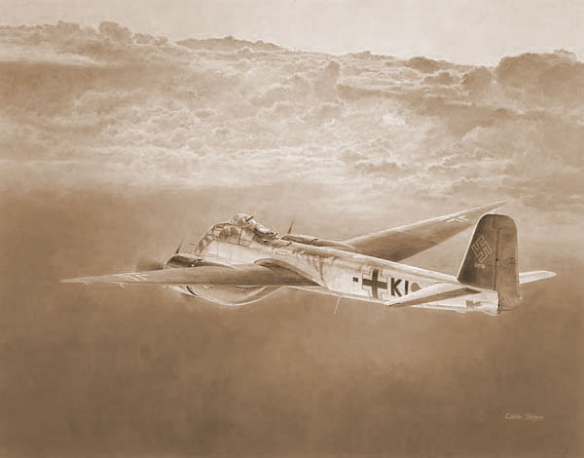
Nakajima type4 fighter hayate [japon] 1943 Junkers ju188e-1 bomber [allemagne] 1943

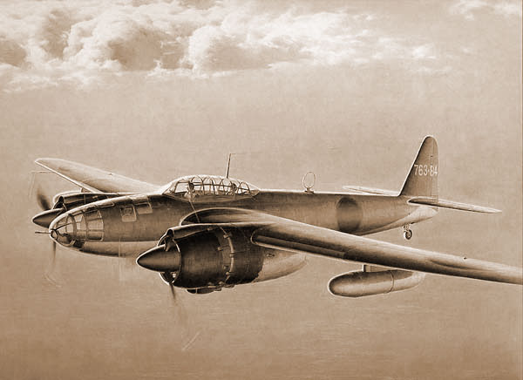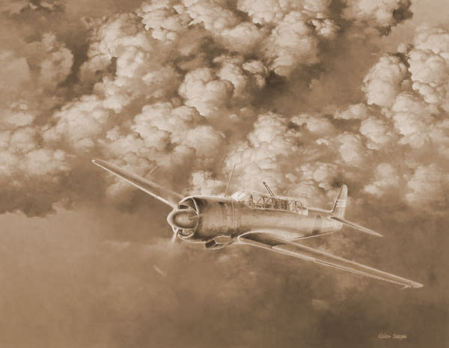
Naval aero -technical arsonal dive- bomber ginga Nakajima night fighter saiun [japon] [japon] 1943 1943

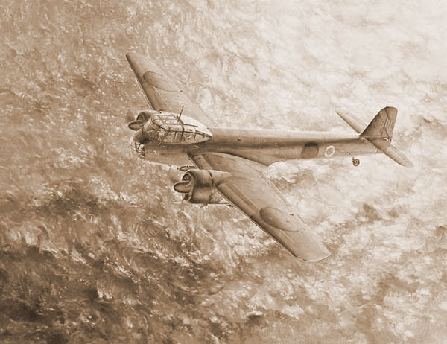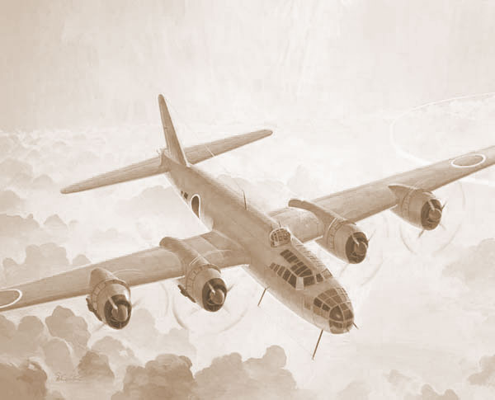
Kyushu anti-submarine patorol aircraft tohkai Nakajima attack-bomber renzan [japon [japon] 1944 navy] 1944

